 | Monday | Notes
Before Camp Starts | - Set the studio up following Covid guidelines (open windows, turn on fans, turn on air purifier, adjust AC  - Thread machines  - Make sure bobbins are full and that you have extra pre-wound bobbins  - Have all of the materials and supplies for the day ready
1pm - 1.15pm  Welcome Meeting | - Meet ‘n’ Greet  - Welcome Meeting  - Share “My name is…and I learned to sew at/when…”  Go around the room asking everyone to share where they learned to sew or if they have never sewn before what they are most looking forward to.  - Goals for the week -  - To learn how to hand sew and machine sew  - To make a Pillow, Tic-Tac-Toe Travel Game, Keychain & Bookmark  - To make new friends  - To have a fun camp experience  - Goals for today -  - To learn how to thread a needle, tie a knot and straight stitch  - To learn how to use a sewing machine  - Safety (General)
1.15pm - 1.35pm  Welcome Activity | iPhone Activity 1  - Hand “All About Me” Sheets  - Campers should spend 15 minutes completing the questionnaires  - Go around the room asking campers to tell everyone about themselves  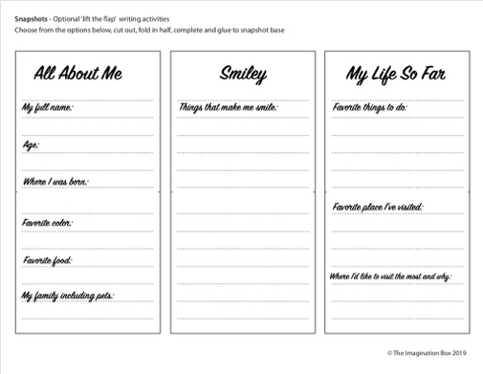 | Supplies Needed:  - iPhone “All About Me” Sheets  - Markers/Pens/Pencils
1.35pm - 2.30pm  Activity 1  Hand Sewing | - Demonstrate threading a needle and tying a knot  - Campers practice threading a needle and tying a knot  - Demonstrate how to cut fabric  - Campers cut out the bookmark, front & back  - Demonstrate straight stitch  - Campers start stitching first stitch line on bookmark  - At the end of the first line demonstrate the lock stitch  - Campers do a lock stitch, cut their thread and start the entire process again (thread a needle and tie a knot)  - Continue on to next stitch line  - Continue stitching straight lines on bookmark  - If a camper completes all the straight lines:  - Pin the bookmark back to bookmark front  - Demonstrate the whipstitch  - Camper stitches the bookmark together using a whipstitch | Supplies Needed:  - Needles (#6)  - Pincushions  - Needle threaders  - Scissors  - Floss  - Bookmark  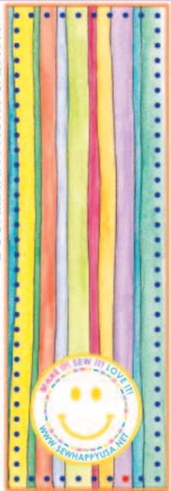
BREAK
2.30pm - 2.45pm
2.45pm - 3.45pm  Activity 2 Machine Sewing | - Basic Anatomy of Sewing Machine (10 Minutes)  - With machines in front of students discuss the following keywords:  - On/Off Switch  - Bobbin  - Thread  - Needle  - Presser Foot  - Balance Wheel  - Presser Foot Lever  - Foot Pedal  - Safety (2-3 Minutes)  - Discuss safety hazards  - Electrical Cords - be careful not to trip  - Sharp pins & needles on floor - keep shoes on  - Keep long hair away from machine  - Keep closed toed shoes on  - Start To Sew Felt Pouch  With speed on SLOW, start to stitch:  - Start with STRAIGHT stitch on the larger box  - Pivots/Corners (Explain how to lift presser foot and swivel while the needle STAYS in the felt)  - Curves (Demonstrate how to lift the presser foot making small turns as you sew around the curve).  - If time allows - Sew button on the “X”. | 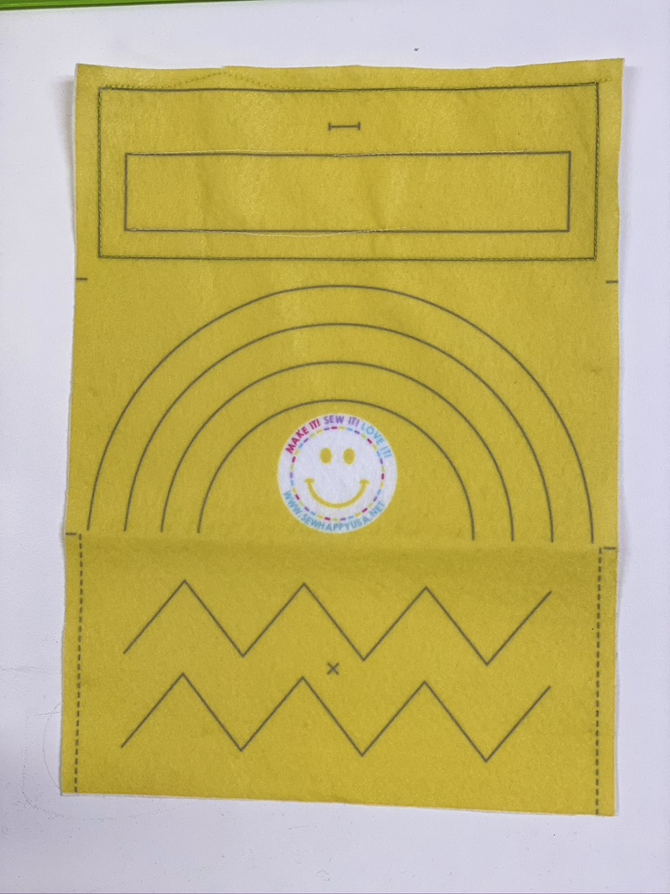
3.45pm - 4pm  Clean Up / Show & Tell | - Campers should put all of their materials in their ziplock bag (Campers should write their name on a label and stick to front of bag).  - Hand each camper a wipe and ask them to wipe their work station including the hand wheel on the sewing machine and the desktop.  - Instructor - do show and tell today and tell the campers they are welcome to bring a show & tell item any day during camp  - Ask campers to share “What I liked about Day 1 at camp”  - If there is still time ask a “Would You Rather” question or two. | Supplies Needed:  - Ziplock Bag  - Name Label  - Instructor Show & Tell Item
4pm  Dismissal | - Have campers collect their belongings (water bottle, phone etc)  - Have campers line up  - Instructor should lead the group down to the pick-up location in a quiet and orderly manner  - Follow dismissal procedure  - Return to studio, sanitize and clean so it’s ready for next class

 | Tuesday | Notes
Before Camp Starts | - Set the studio up following Covid guidelines (open windows, turn on fans, turn on air purifier, adjust AC  - Thread machines  - Make sure bobbins are full and that you have extra pre-wound bobbins  - Have all of the materials and supplies for the day ready
1pm - 1.15pm  Welcome Meeting | - Welcome Meeting  Go around the room asking everyone to say a simple fact about themselves (their favorite candy, best friend’s name etc.  - Goals for the week -  - To learn how to hand sew and machine sew  - To make a Pillow, Tic-Tac-Toe Travel Game, Keychain & Bookmark  - To make new friends  - To have a fun camp experience  - Goals for today -  - To continue sewing the bookmark  - To start to make the Retro Music Pillow  - Safety (General)
1.15pm - 1.35pm  Welcome Activity | iPhone Activity 2  - Hand “All About Me” Sheets  - Campers should color the base iphone and glue the pages to it  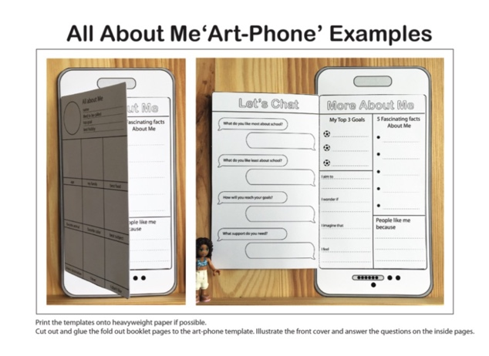 | Supplies Needed:  - iPhone Base Template Sheets  - Markers  - Glue Sticks
1.35pm - 2.30pm  Activity 1  Hand Sewing | - Refresher of threading a needle and tying a knot  - Campers practice threading a needle and tying a knot  - Demonstrate the whipstitch  - Pin the bookmark back to bookmark front  - Demonstrate the whipstitch  - Camper stitches the bookmark together using a whipstitch | Supplies Needed:  - Needles (#6)  - Pincushions  - Needle threaders  - Scissors  - Floss
BREAK
2.30pm - 2.45pm
2.45pm - 3.45pm  Activity 2 Machine Sewing | - Cut pillow, pocket and handle (students choose from boombox or headphones pocket)  - Pin & Stitch pocket to pillow  - Pin & Stitch Handle to pillow  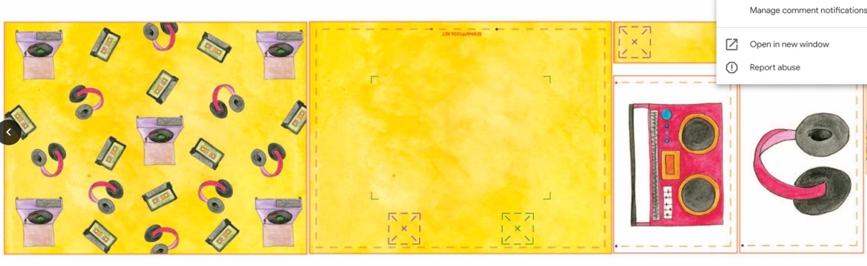
3.45pm - 4pm  Clean Up / Show & Tell | - Campers should put all of their materials in their ziplock bag (Campers should write their name on a label and stick to front of bag).  - Hand each camper a wipe and ask them to wipe their work station including the hand wheel on the sewing machine and the desktop.  - Instructor - do show and tell today and tell the campers they are welcome to bring a show & tell item any day during camp  - Ask campers to share “What I liked about camp today”  - If there is still time ask a “Would You Rather” question or two.
4pm  Dismissal | - Have campers collect their belongings (water bottle, phone etc)  - Have campers line up  - Instructor should lead the group down to the pick-up location in a quiet and orderly manner  - Follow dismissal procedure  - Return to studio, sanitize and clean so it’s ready for next class

 | Wednesday | Notes
Before Camp Starts | - Set the studio up following Covid guidelines (open windows, turn on fans, turn on air purifier, adjust AC  - Thread machines  - Make sure bobbins are full and that you have extra pre-wound bobbins  - Have all of the materials and supplies for the day ready
1pm - 1.15pm  Welcome Meeting | - Welcome Meeting  Go around the room asking everyone to say a simple fact about themselves (their favorite candy, best friend’s name etc.  - Goals for the week -  - To learn how to hand sew and machine sew  - To make a Pillow, Tic-Tac-Toe Travel Game, Keychain & Bookmark  - To make new friends  - To have a fun camp experience  - Goals for today -  - To cut and sew the tic-tac-toe counters  - To complete the Retro Music Pillow  - Safety (General)
1.15pm - 1.35pm  Welcome Activity | iPhone Activity 3  - Hand out “iPhone Coloring” Sheets  - Campers color  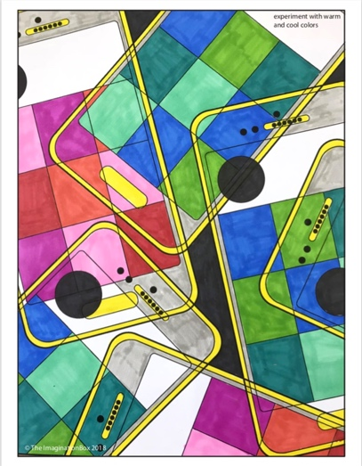 | Supplies Needed:  - iPhone Coloring Sheet  - Markers
1.35pm - 2.30pm  Activity 1  Hand Sewing | - Cut tic-tac-toe counters  - Pin & stitch using a whipstitch  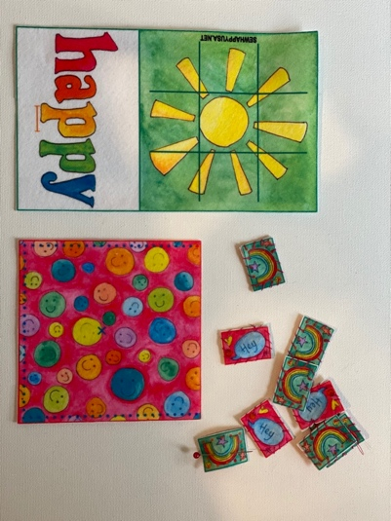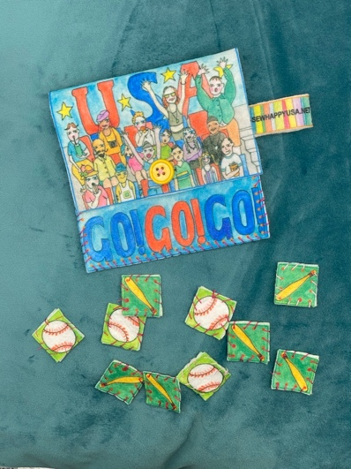 | Needles (#6)  Pincushions  Needle threaders  Scissors  Floss  Tic-tac-toe
BREAK
2.30pm - 2.45pm
2.45pm - 3.45pm  Activity 2 Machine Sewing | - Pin & Stitch pillow together (wrong sides together)  - Stuff pillow  - Hand sew opening closed  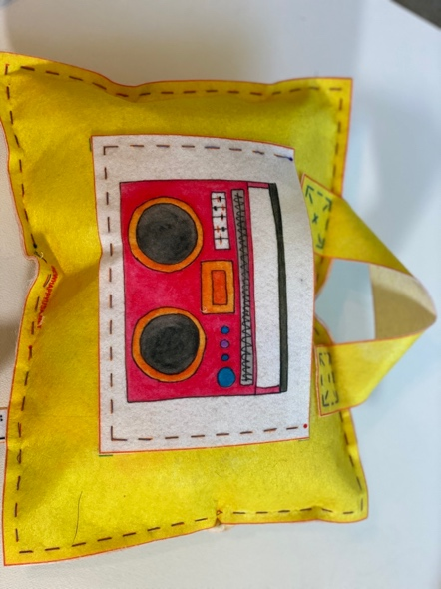 (Machine Stitch)
3.45pm - 4pm  Clean Up / Show & Tell | - Campers should put all of their materials in their ziplock bag (Campers should write their name on a label and stick to front of bag).  - Hand each camper a wipe and ask them to wipe their work station including the hand wheel on the sewing machine and the desktop.  - Instructor - do show and tell today and tell the campers they are welcome to bring a show & tell item any day during camp  - Ask campers to share “What I liked about camp today ”  - If there is still time ask a “Would You Rather” question or two.
4pm  Dismissal | - Have campers collect their belongings (water bottle, phone etc)  - Have campers line up  - Instructor should lead the group down to the pick-up location in a quiet and orderly manner  - Follow dismissal procedure  - Return to studio, sanitize and clean so it’s ready for next class

 | Thursday | Notes
Before Camp Starts | - Set the studio up following Covid guidelines (open windows, turn on fans, turn on air purifier, adjust AC  - Thread machines  - Make sure bobbins are full and that you have extra pre-wound bobbins  - Have all of the materials and supplies for the day ready
1pm - 1.15pm  Welcome Meeting | - Welcome Meeting  Go around the room asking everyone to say a simple fact about themselves (their favorite candy, best friend’s name etc.  - Goals for the week -  - To learn how to hand sew and machine sew  - To make a Pillow, Tic-Tac-Toe Travel Game, Keychain & Bookmark  - To make new friends  - To have a fun camp experience  - Goals for today -  - To sew the keychain  - To sew the tic-tac-toe pouch  - Safety (General)
1.15pm - 1.35pm  Welcome Activity | Musical Instrument Wordsearch  - Hand out “Music Wordsearch” Sheets  - Campers try to complete it  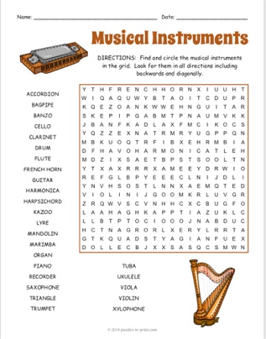 | Supplies Needed:  - Music Wordsearch Sheet  - Markers
1.35pm - 2.30pm  Activity 1  Hand Sewing | - Cut keychain  - Insert keyring  - Pin & stitch using a whipstitch  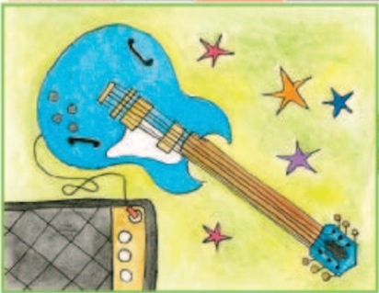 | Supplies Needed:  - Needles (#6)  - Pincushions  - Needle threaders  - Scissors  - Floss  - Keychain
BREAK
2.30pm - 2.45pm
2.45pm - 3.45pm  Activity 2 Machine Sewing | - Tic-tac-toe pouch - stitch button on “X”  - Fold on dashed line  - Pin and stitch sides  - Cut buttonhole  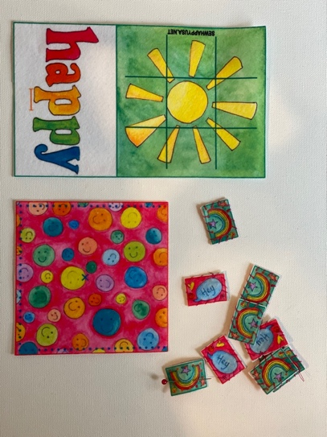
3.45pm - 4pm  Clean Up / Show & Tell | - Campers should put all of their materials in their ziplock bag (Campers should write their name on a label and stick to front of bag).  - Hand each camper a wipe and ask them to wipe their work station including the hand wheel on the sewing machine and the desktop.  - Instructor - do show and tell today and tell the campers they are welcome to bring a show & tell item any day during camp  - Ask campers to share “What I liked about camp today ”  - If there is still time ask a “Would You Rather” question or two.
4pm  Dismissal | - Have campers collect their belongings (water bottle, phone etc)  - Have campers line up  - Instructor should lead the group down to the pick-up location in a quiet and orderly manner  - Follow dismissal procedure  - Return to studio, sanitize and clean so it’s ready for next class

 | Friday | Notes
Before Camp Starts | - Set the studio up following Covid guidelines (open windows, turn on fans, turn on air purifier, adjust AC  - Thread machines  - Make sure bobbins are full and that you have extra pre-wound bobbins  - Have all of the materials and supplies for the day ready
1pm - 1.15pm  Welcome Meeting | - Welcome Meeting  Go around the room asking everyone to say a simple fact about themselves (their favorite candy, best friend’s name etc.  - Goals for the week -  - To learn how to hand sew and machine sew  - To make a Pillow, Tic-Tac-Toe Travel Game, Keychain & Bookmark  - To make new friends  - To have a fun camp experience  - Goals for today -  - To complete all of the projects  - Safety (General)
1.15pm - 1.35pm  Welcome Activity | Kindness Rocks  - Hand out rocks and sharpies  - Show samples to campers  - Campers color their rocks in the theme of “Kindness”   | Supplies Needed:  - Rocks  - Sharpies
1.35pm - 2.30pm  Activity 1  Hand Sewing | Complete all projects:  - Bookmark  - Keychain  - Tic-tac-toe  - Pillow
BREAK
2.30pm - 2.45pm
2.45pm - 3.45pm  Activity 2 Machine Sewing | If all projects are complete:  FREE SEW (make sure to follow Free Sew guidelines)
3.45pm - 4pm  Clean Up / Show & Tell | - Campers should have all their projects ready to take home  - Hand each camper a wipe and ask them to wipe their work station including the hand wheel on the sewing machine and the desktop.  - Final show and tell  - Ask campers to share “What I liked about camp today ”  - If there is still time ask a “Would You Rather” question or two.
4pm  Dismissal | - Have campers collect their belongings (water bottle, phone etc)  - Have campers line up  - Instructor should lead the group down to the pick-up location in a quiet and orderly manner  - Follow dismissal procedure  - Return to studio, sanitize and clean so it’s ready for next class  - Put away any excess materials from students’ ziplock bags, remove name labels and put in office for recycling - thank you.

