Quilted Tote Bag Weeks 6, 7 & 8 - Construct The Bag

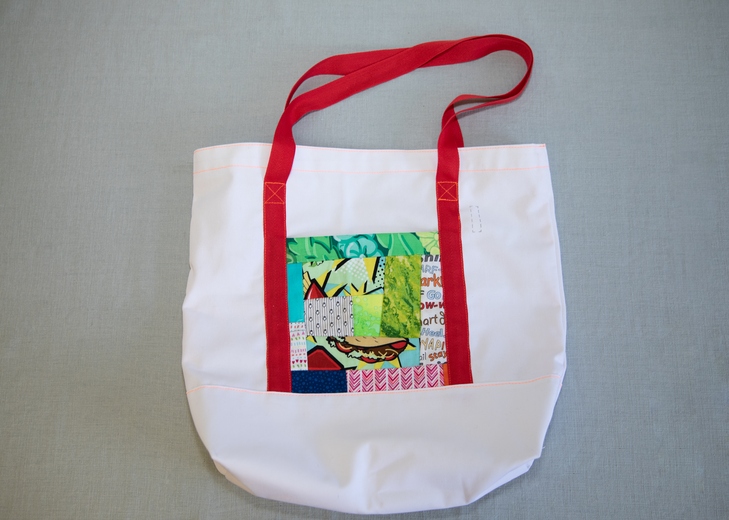

Additional Materials Required:

- Tote Bag Fabric
- Base Fabric
- Nylon Webbing (straps)

Construct The Bag
- Pockets

- Pin the EZ Strips piece to the tote bag making sure the EZ Strips fabric is ½” below the gray line and ½” over the gray lines at either side (Make sure the finished edge is at the TOP)
- Stitch in place along the bottom edge making sure stitch line is BELOW the gray line
- Pin one strap in place making sure that both ends of the strapping are BELOW the gray line. Use plenty of pins to hold the strap in place while you stitch
- Carefully stitch strap on the tote bag fabric, close to edge. Stitch both sides of strap. Stitch a decorative “X” in a box as shown in the photo and as marked on the tote bag
- Repeat with the QAYG fabric piece on the other side of the tote bag

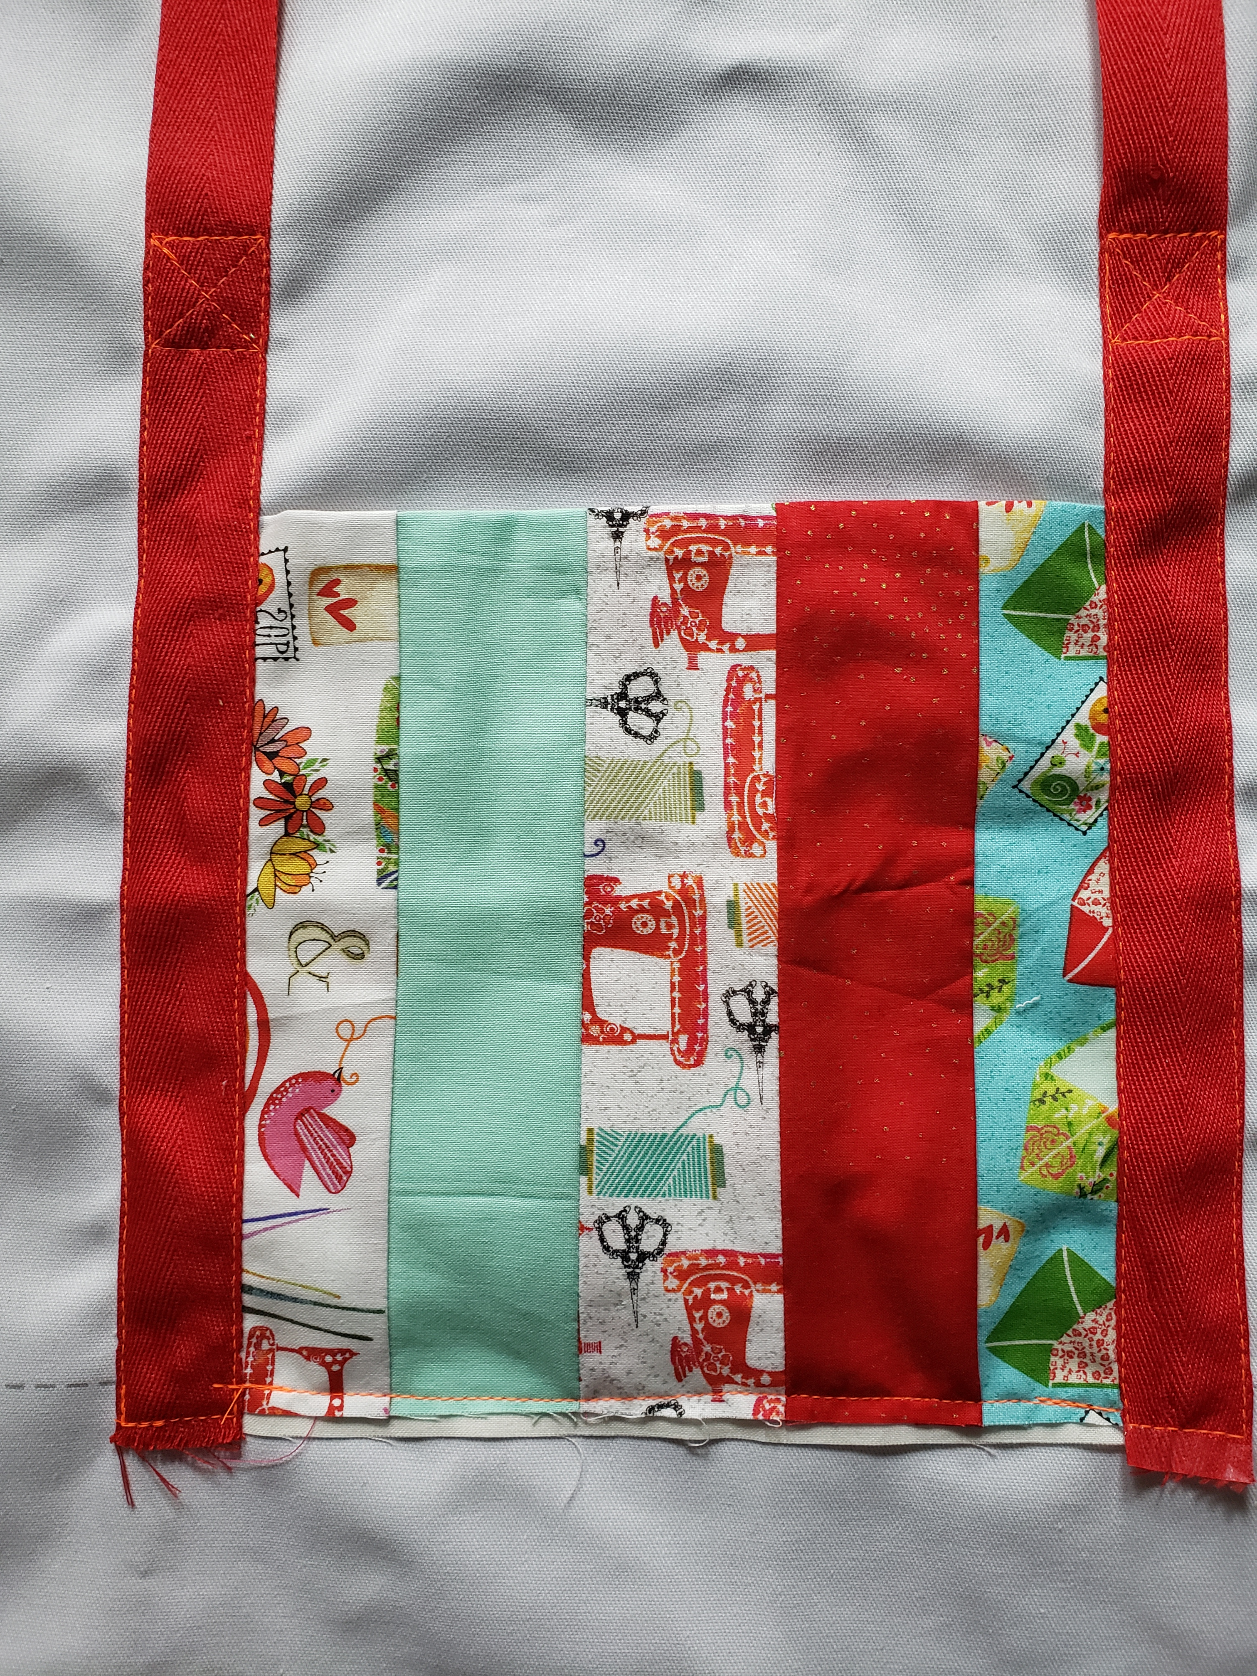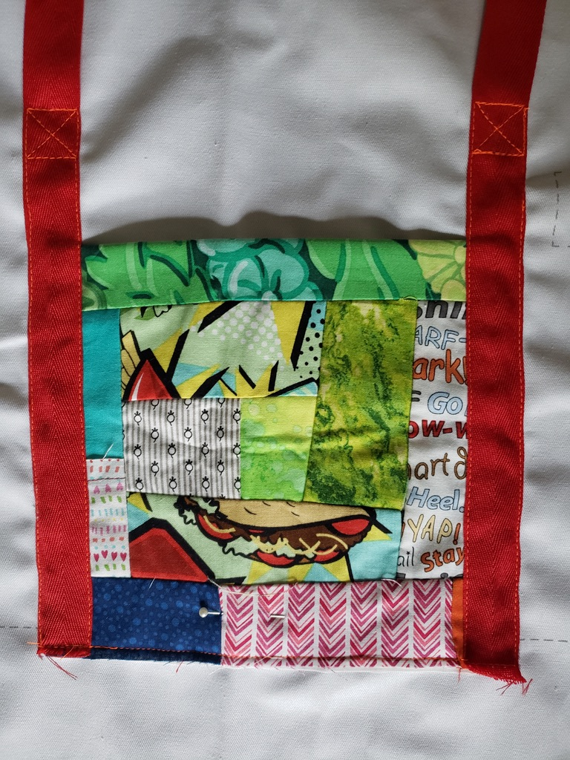

- Add Bag Base

- Draw a stitch line on the back of bag base ½” from one of the long edges (using a ruler and frixion marker)
- With RST place bag base on bag fabric as shown in photo (the stitch line you drew should line up with gray line on bag fabric)
- Pin in place and stitch

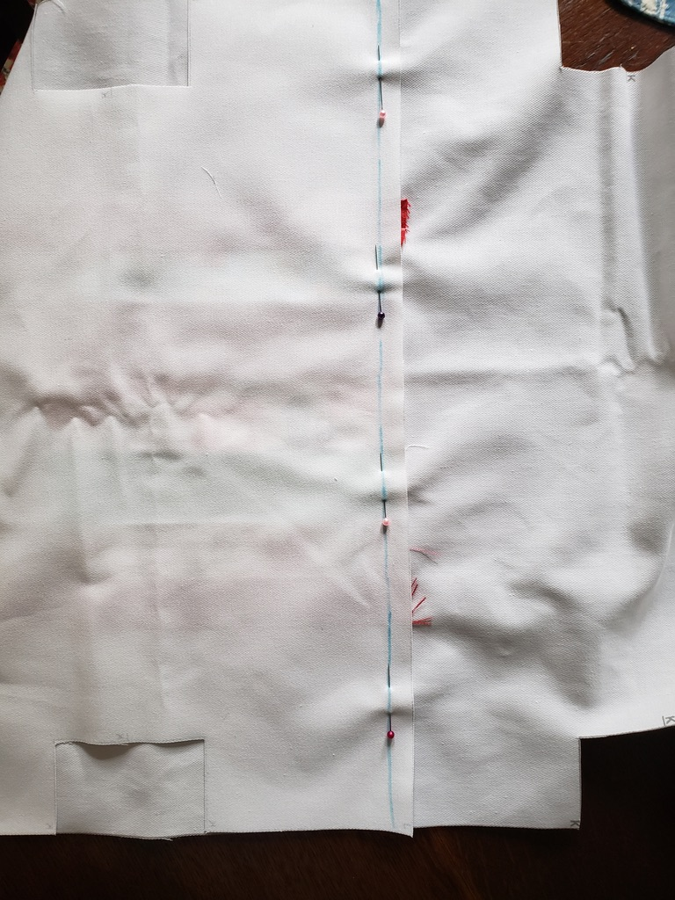

- Fold bag base fabric on the stitch line

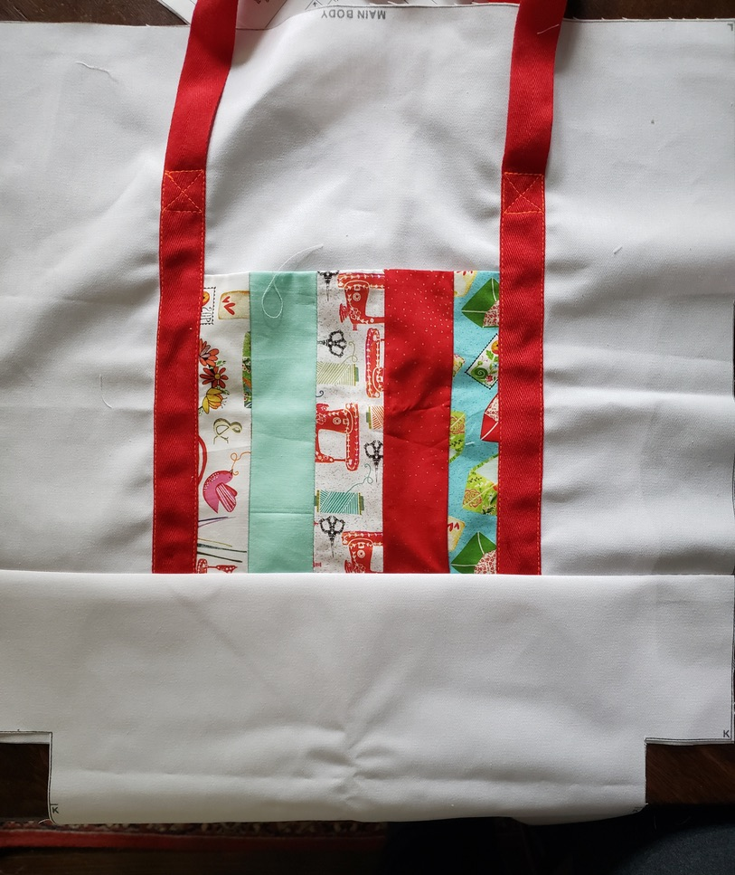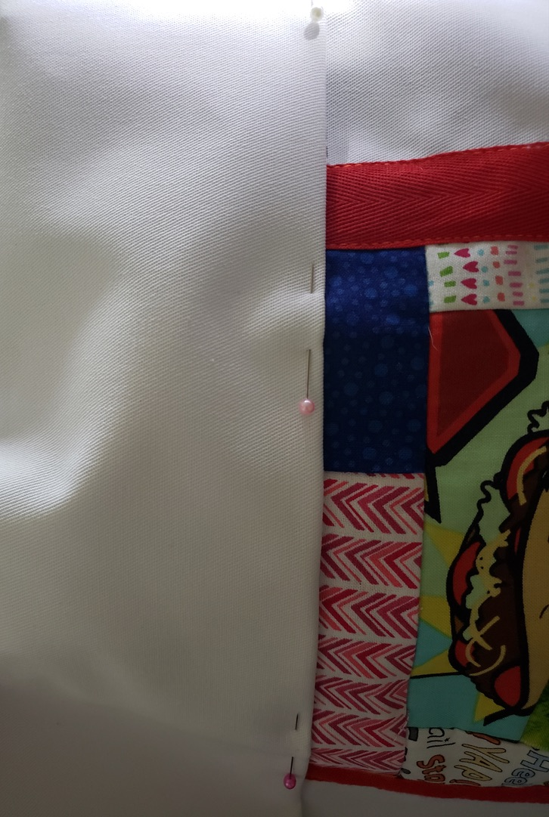

- Turn under a ½” seam and pin the other long edge to gray line on the other side of the tote bag fabric

- Top stitch along both edges, as close to the edge as possible (draw a stitch line with a frixion marker)

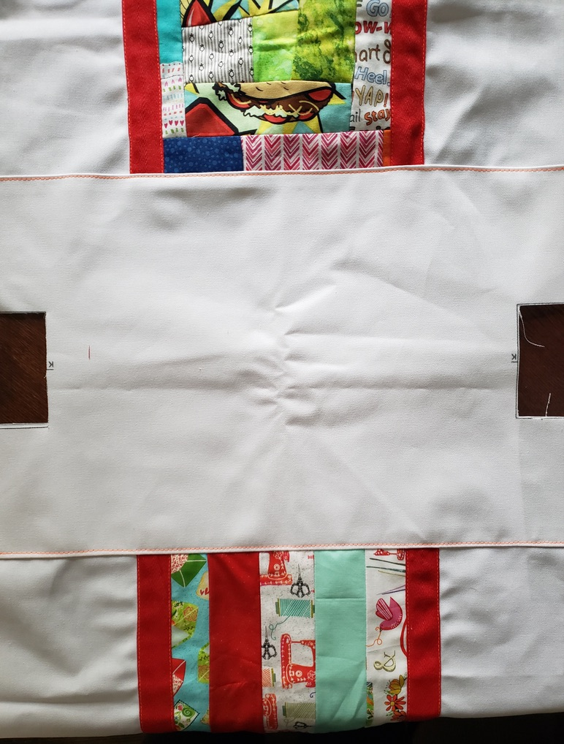

- Stitch Bag
- With RST fold tote bag fabric in half matching edges
- Draw a stitch line with a frixion marker
- Pin along the stitch line
- Stitch
- Use stitch #6 to overcast the raw edges
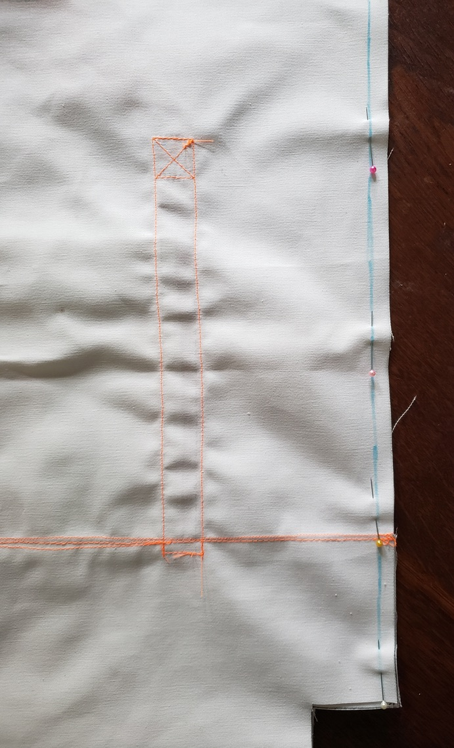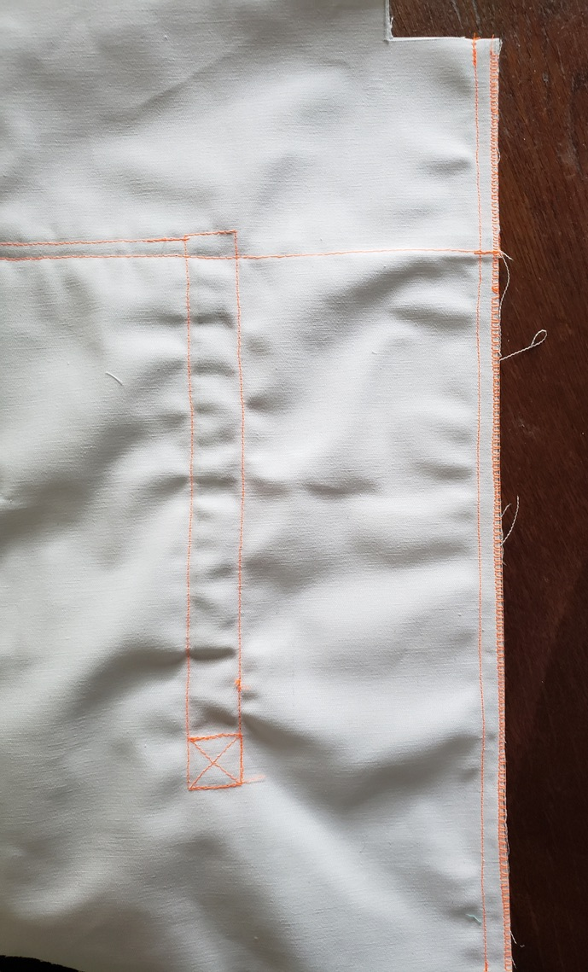

- Box Bottom

  - Measure 2 ½” from corner and draw a line.

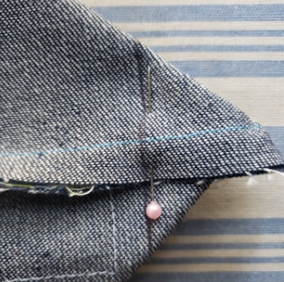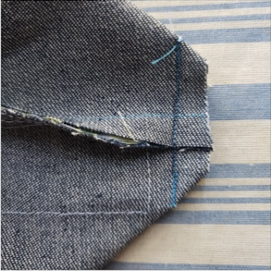
- Straight stitch along the marked line.
- Trim the extra fabric off.
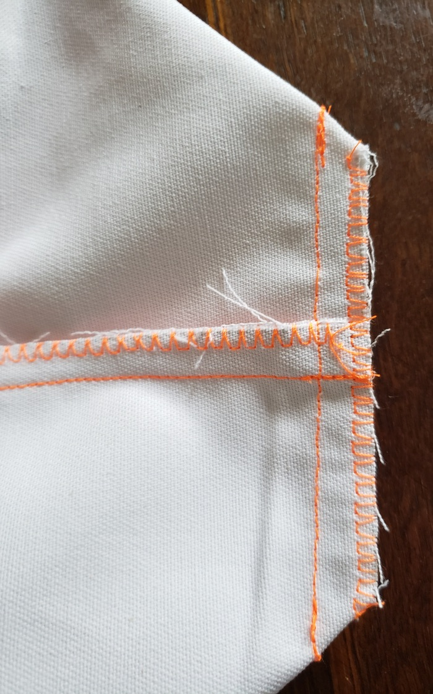

- Use stitch 6 to overcast the raw edge (or zigzag stitch is fine too).

- Final Step
- Turn bag to right side
- Trim any hanging threads
- Add a ribbon “tag” at the gray box marked on the tote bag fabric

Your quilted tote bag is complete. Enjoy!

