HEDGEHOG HOUSE

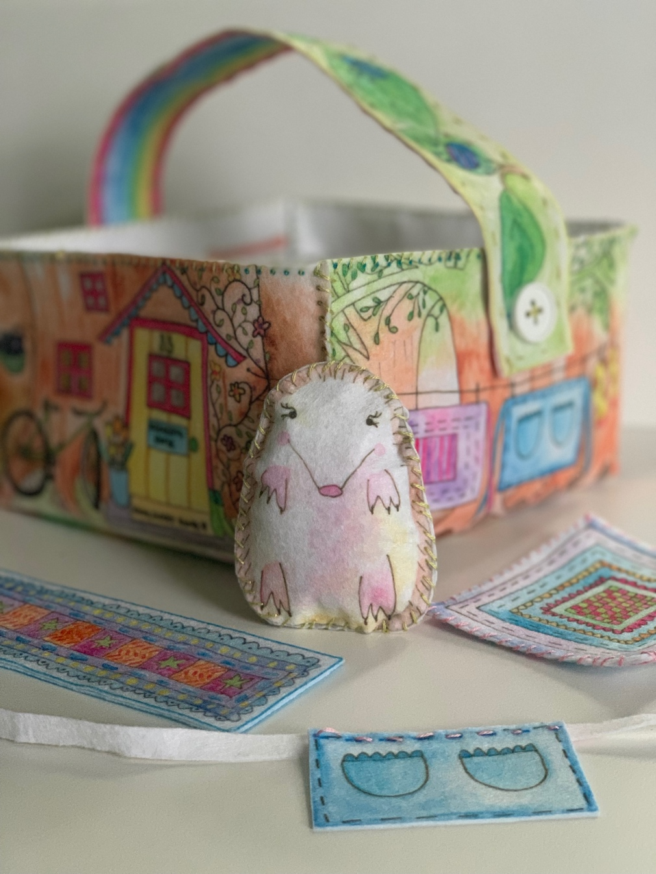

INSTRUCTOR PREPARATION

- CUT:  BLANKET BACK (This is practice piece)  - THREAD and KNOT one needle per student | 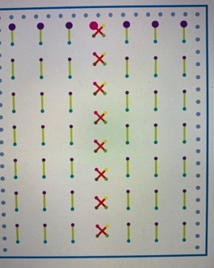
REMINDERS & DEMONSTRATIONS

Refer To “First Class” in The Sew Happy Instructor Training (Can Be Found In Instructor Binder)

WEEK 1
NOTES FOR INSTRUCTOR:
- If a student is behind you may do any of the following:
  - SKIP the POCKET
  - Use one side of STRAP instead of two
  - Blanket does not need to be completed, they can use one side for their finished project
- Bookmark is an extra project, doesn’t have to be completed
- Keychain is only if students are ahead. Don’t mention it in the beginning as it’s likely you won’t get to it in a 9 week session.
- Hedgehog clothing is for longer classes.

WEEK 1 SEWING STEPS

1. | Introduction & Demo | SEE SEPARATE NOTES  FOR WEEK 1
2. | The Practice Piece today is:  - Blanket Back
3. | Starting at one of the LARGE PURPLE DOTS close to the edge of the fabric, insert needle in the back of the fabric and pull the needle all the way through.  Insert needle in small blue dot and pull until the thread is all the way through. Repeat this “STAB STITCH” method and sew along the GREEN STITCH LINES until you get to the end of the first row of stitches.  With your needle at the back of the BLANKET, make a LOCK STITCH (by leaving a small loop and pulling needle through the loop).  Cut thread close to LOCK STITCH.  Students should now take a new piece of floss and try to thread their needles. Start another row of stitches beginning at one of the other LARGE PURPLE DOTS. | 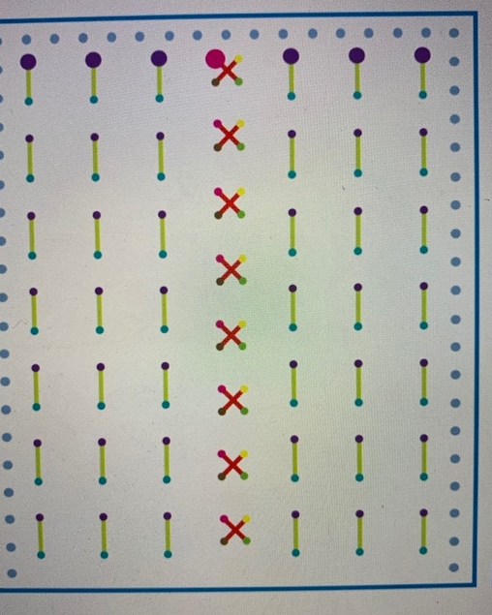
TIP! | STAB STITCH: Insert the needle in to the fabric and pull all the way through. Once a student has mastered the STAB STITCH, he/she can start to do the RUNNING STITCH where the needle is inserted in to the fabric and out again in one motion.
 | *EXTRA WORK*  Extra activities for students who finish early:  Add more stitching to BLANKET BACK. | Do NOT allow any student to move on to the next step!

INSTRUCTOR PREPARATION

- CUT:  - INSIDE BASKET  - BLANKET FRONT  - THREAD and KNOT one needle per student. | 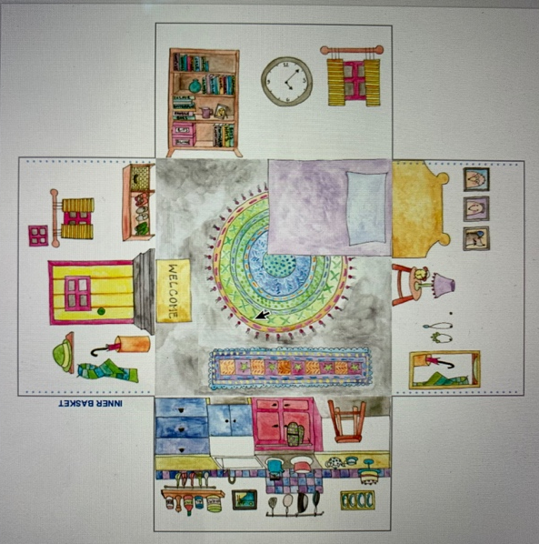
REMINDERS & DEMONSTRATIONS

- Weekly Meeting & Classroom Rules  - DEMO threading a needle using the needle threader and pincushion technique.  This week the demo and practice SHOULD TAKE 15 MINUTES | - PRACTICE - Give each student a pincushion, needle and needle threader and have them practice threading the needle and tying a knot around the needle.  - REMIND students about LOCK STITCH
WEEKS 2 & 3

WEEKS 2 & 3 SEWING STEPS

1. | Reminders & Demo  DO NOT SKIP THIS STEP! | (See Previous Page)
2. | Hand each student:  - Basket INSIDE
3. | - Match any 2 edges of the basket together.  - PIN along edge (2 Pins).  - Starting at top of basket and following the dotted stitch marks, stitch the 2 edges together using a WHIP STITCH, making sure to insert the needle in each DOT.  - WHIP STITCH – with dots facing up, insert needle through back of fabric so it comes up through a dot4. Pull thread all the way through. Repeat moving to the next DOT each time.  - Repeat for other edges of basket | 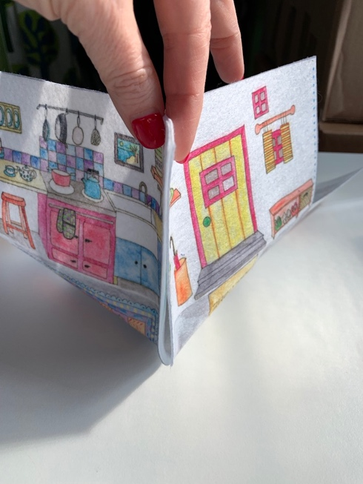  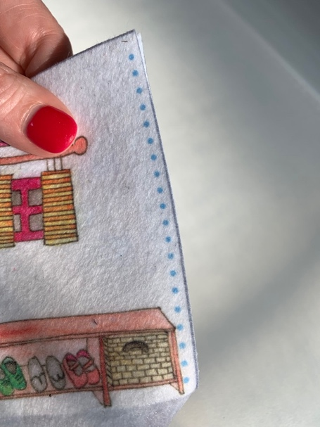  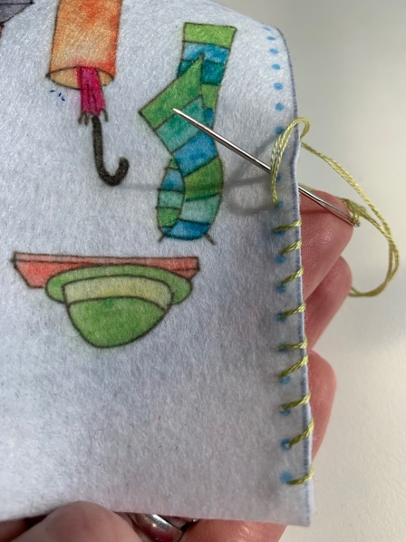
TIP! | As a student finishes their thread they can try to thread their own needle using the pincushion and needle threader technique.
 | *EXTRA WORK*  Extra activities for students who finish early:  During Week 2 there shouldn’t be any student who has completed all 4 sides.  Week 3: Start embellishing BLANKET FRONT (Students can get creative and make their own designs).  Do NOT allow any student to move on to the next step! | 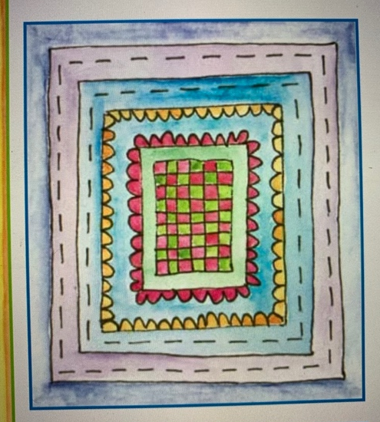

WEEK 4
INSTRUCTOR PREPARATION

- CHECK:  In each student’s bag and catch up anyone who can’t move forward to next week’s steps  - CUT:  - POCKET  - BASKET OUTSIDE  - THREAD and KNOT one needle per student. | 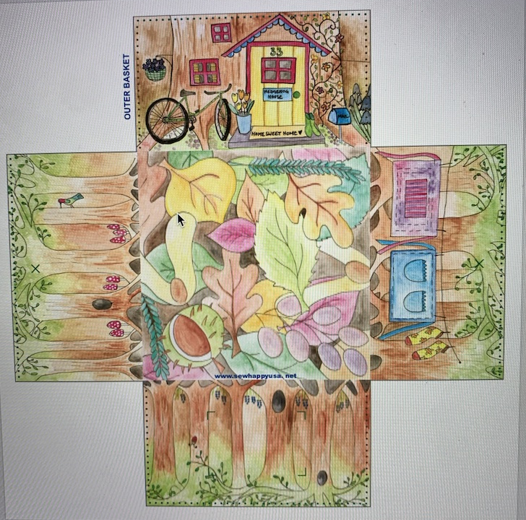  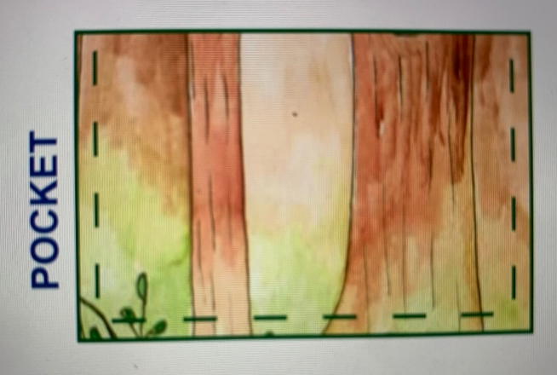

REMINDERS & DEMONSTRATIONS

- Welcome Meeting & Classroom Rules  - REFRESHER - threading a needle using the needle threader and pincushion technique.  - REFRESHER - TYING A KNOT and LOCK STITCH  This week the demo and practice SHOULD TAKE 10 MINUTES | - Practice - Give each student a pincushion, needle and needle threader and have them practice threading the needle, tying a knot around the needle and tying a knot at the end of their thread.

WEEK 4 SEWING STEPS
1. | Reminders & Demo  DO NOT SKIP THIS STEP!
2. | Hand each student:  - BASKET OUTSIDE  - POCKET
3. | - Match up the pocket to the pattern on basket.  - PIN in place.  - STITCH around 3 sides leaving the top open.  - Use the same instructions as the INSIDE BASKET to sew the edges of the OUTSIDE BASKET together  - Insert “MADE BY” label in one of the edges  - (We will continue this next week)  TIP – Remind students to stop when their floss gets to 4” long (use laminated rulers in instructor bin). They need to stop and make a LOCK STITCH | 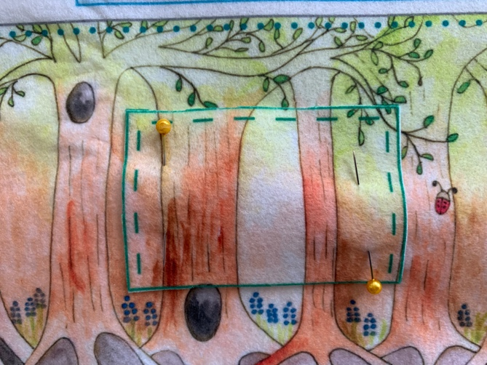
 | *EXTRA WORK*  Most students will not complete BASKET BACK in one class but if they do:-  Extra activities for students who finish early:  - Continue working on BLANKET. | Do NOT allow any student to move on to the next step!

INSTRUCTOR PREPARATION

- CUT:

- CHECK:
In each student’s bag and catch up anyone who can’t move forward to next week’s steps

- THREAD and KNOT one needle per student.

REMINDERS & DEMONSTRATIONS

- Welcome Meeting & Classroom Rules  - REFRESHER - threading a needle using the needle threader and pincushion technique.  - REFRESHER - TYING A KNOT and LOCK STITCH  This week the demo and practice SHOULD TAKE 10 MINUTES | - Practice - Give each student a pincushion, needle and needle threader and have them practice threading the needle, tying a knot around the needle and tying a knot at the end of their thread.
WEEK 5

1. | Reminders & Demo  DO NOT SKIP THIS STEP!
2. | Hand each student:  - Outside Basket (already in students’ bags)  - 2 Buttons
3. | - Continue sewing the BASKET BACK until all 4 sides are stitched.  - Locate the 2 X’s on the sides of the OUTSIDE BASKET.  - Stitch buttons on (this is where strap will attach). | 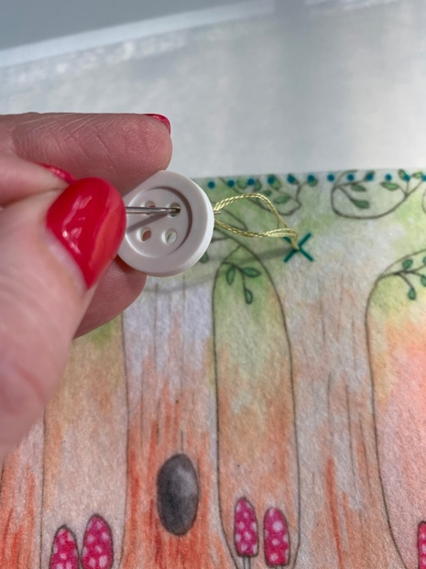
 | *EXTRA WORK*  Continue BLANKET | Do NOT allow any student to move on to the next step!

WEEK 6

INSTRUCTOR PREPARATION

- CHECK:
In each student’s bag and catch up anyone who can’t move forward to next week’s steps.
- THREAD and KNOT one needle per student.
- CUT STRAP FRONT & STRAP BACK
- CUT buttonholes in straps
- BRING bookmark but students can cut themselves

REMINDERS & DEMONSTRATIONS

- Welcome Meeting & Classroom Rules  - DEMO threading a needle using the needle threader and pincushion technique.  - DEMO TYING A KNOT and LOCK STITCH  This week the demo and practice SHOULD TAKE 5 MINUTES | - PRACTICE - Give each student a pincushion, needle and needle threader and have them practice threading the needle, tying a knot around the needle and tying a knot at the end of their thread.  - REMIND students about LOCK STITCH and KNOT.

WEEK 6 SEWING STEPS
1. | Reminders & Demo  DO NOT SKIP THIS STEP!
2. | Hand each student:  STRAP FRONT  STRAP BACK
3. | - Pin STRAP FRONT to STRAP BACK  - Using a straight stitch, sew around strap following stitch lines.
 | *EXTRA WORK  - If a student finishes early and has completed everything, continue working on BOOKMARK (Hand students the bookmark front and back and allow them to cut themselves. If they make a mistake when cutting they can use a fabric “bandaid” to fix it (sew it over the mistake). | DO NOT LET A STUDENT MOVE ON TO THE NEXT STEP!

WEEKS 7 & 8

INSTRUCTOR PREPARATION

- CHECK:
In each student’s bag and catch up anyone who can’t move forward to next week’s steps.

- THREAD and KNOT one needle per student.

REMINDERS & DEMONSTRATIONS

- Welcome Meeting & Classroom Rules

- DEMO threading a needle using the needle threader and pincushion technique.

- REMIND students about TYING A KNOT and LOCK STITCH

This week the demo and practice SHOULD TAKE 5 MINUTES

WEEKS 7 & 8 SEWING STEPS

1. | Reminders & Demo  DO NOT SKIP THIS STEP!
2. | Hand each student:  Basket INSIDE  Basket OUTSIDE
3. | - Stitch Baskets Together  - Insert INSIDE BASKET inside OUTSIDE BASKET.  - Match edges and corners so baskets fit snugly together.  - PIN around top edges of basket (1 pin in each side)  - STITCH using a WHIP STITCH. | 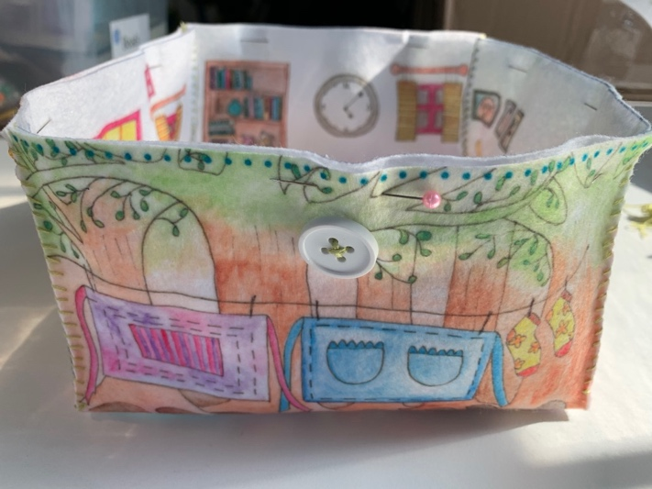
 | *EXTRA WORK  - If a student finishes early and has completed everything including BOOKMARK, work on KEYCHAIN (See instructions at end). | DO NOT LET A STUDENT MOVE ON TO THE NEXT STEP!

WEEK 9
INSTRUCTOR PREPARATION

- CUT:  - STRAP (ONLY THE ONE WITH THE BUGS  - CUT THE BUTTONHOLES IN THE STRAP  - HEDGEHOG (not keychain)  - Piece of fabric with ACCESSORIES (DO NOT CUT individual accessories)  - CHECK:  In each student’s bag and catch up anyone who can’t move forward to next week’s steps.  - THREAD and KNOT one needle per student. | 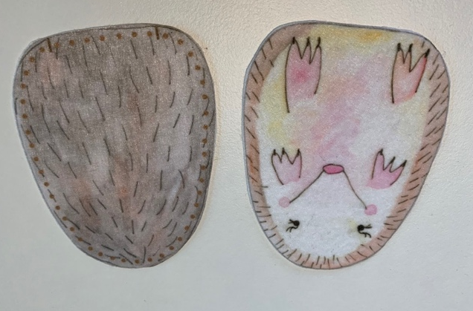
REMINDERS & DEMONSTRATIONS

- Welcome Meeting & Classroom Rules  - DEMO threading a needle using the needle threader and pincushion technique.  - DEMO TYING A KNOT and LOCK STITCH  This week the demo and practice SHOULD TAKE 5 MINUTES | - PRACTICE - Give each student a pincushion, needle and needle threader and have them practice threading the needle, tying a knot around the needle and tying a knot at the end of their thread.  - REMIND students about LOCK STITCH and KNOT.

1. | Reminders & Demo  DO NOT SKIP THIS STEP!
2. | Hand each student:  - HEDGEHOG  - Fabric with HEDGEHOG ACCESSORIES (students can cut themselves)
3. | - Match FRONT and BACK of HEDGEHOG.  - PIN  - Starting at small black mark on bottom edge of HEDGEHOG, STITCH all the way around until the second black mark.  - STUFF  - Stitch opening closed.  DON’T FORGET!  ADD THE STRAP BY FASTENING TO BASKET WITH BUTTONS | 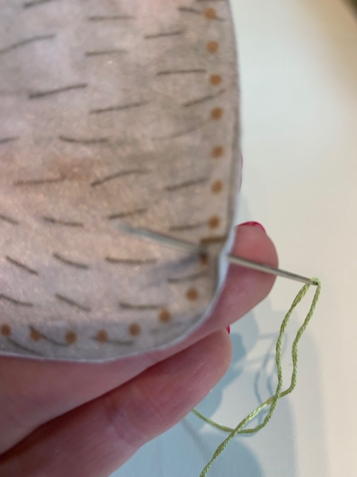
TIP!
Students will need to use a STAB STITCH (one stitch down, one stitch up) as the decorative pieces are so small.
*EXTRA WORK*

Extra activities for students who finish early:
- Keychain or:
- Hand students the piece of fabric with the aprons.
- Let them cut out and stitch apron ties.

YOU ARE FINISHED – WELL DONE!

KEYCHAIN INSTRUCTIONS

1. | Hand each student:  - KEYCHAIN (Let students cut out themselves)  - KEYCHAIN RING  - Fabric with KEYCHAIN ACCESSORIES (students can cut themselves) | 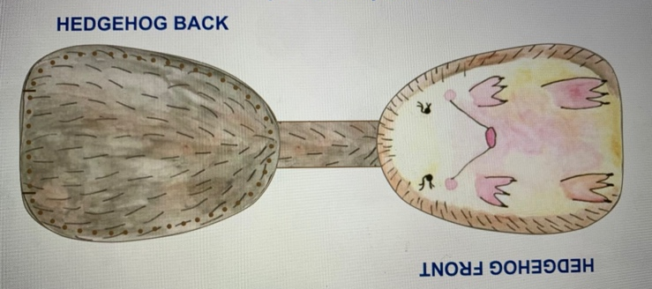
3. | - Slide KEYCHAIN RING over KEYCHAIN FRONT so that it is on the connecting strap  - MATCH KEYCHAIN FRONT & KEYCHAIN BACK  - PIN together  - STITCH around edges
TIP! | Students will need to use a STAB STITCH (one stitch down, one stitch up) as the decorative pieces are so small.

