Appliqued Beach Tote With Zippered Pocket (Optional)
Beginner Sewing 3

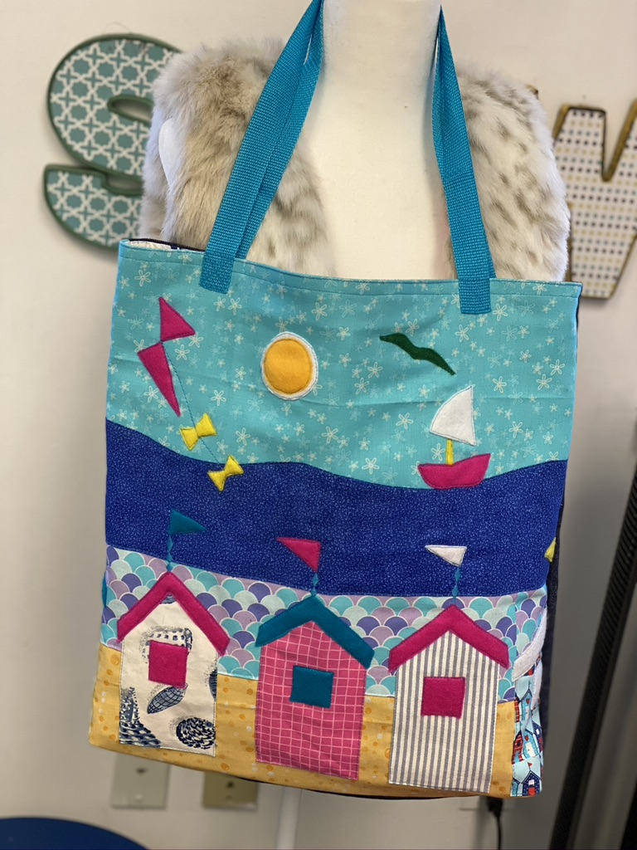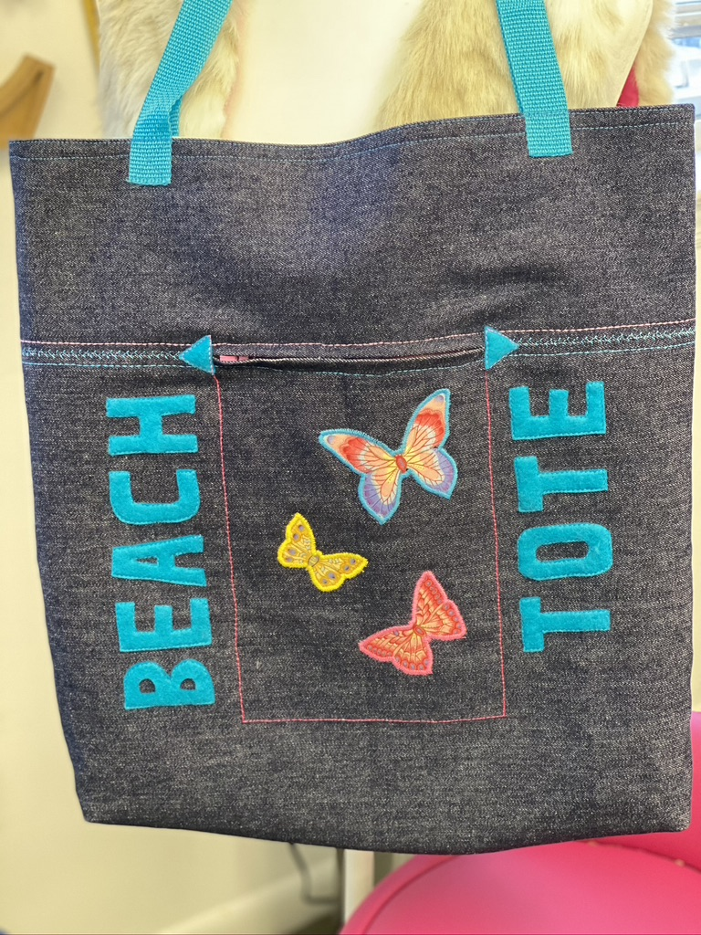

Materials (per student)
Main Fabric:
- 2 pieces of 18 inches x 19 inches (body front and back)
- (If adding zipper - 1 piece of 18” x 19” and 1 piece of 18 inches x 14 inches (body back bottom)+ 1 piece of 6 inches x 18 inches (body back top)

Lining:
- 2 pieces of 18 inches x 19 inches (body front and back)

Other:
- Webbing for straps
- One 7” zipper (if adding zipper):

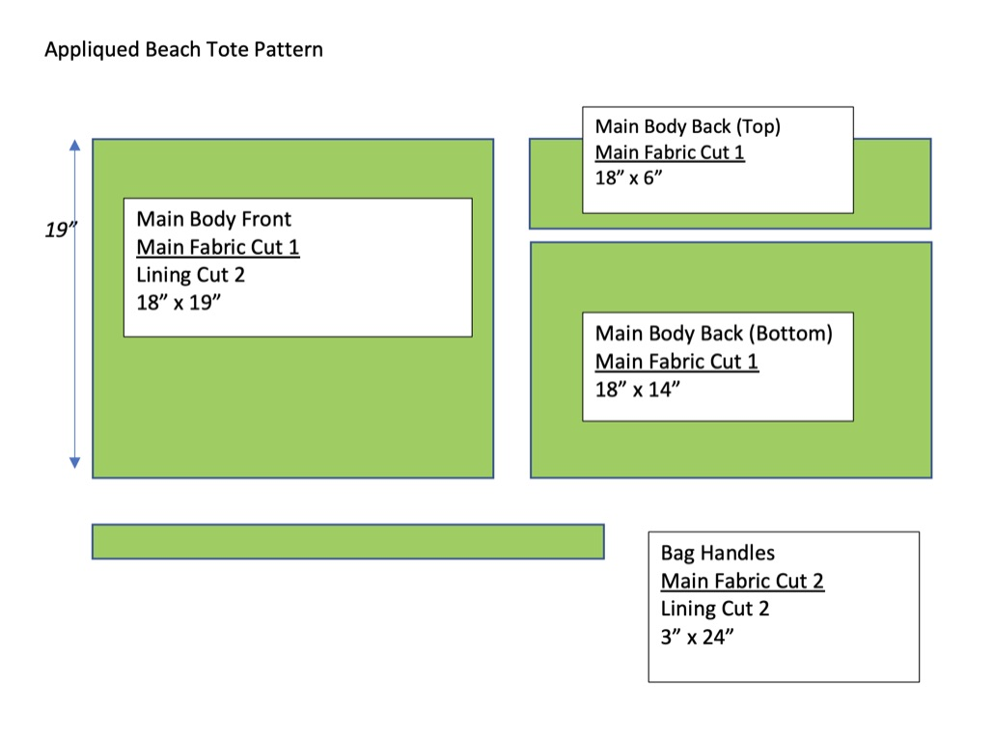

Class 1

- Use paper and pencils/markers to design bag (show students ideas, students can look through fabrics to plan their design)
- Start applique if ready

Students should be aware that there is a box bottom and the lower 3 inches will be the base of the bag. There is also ½” seam allowance at the top and sides of the bag that won’t show.

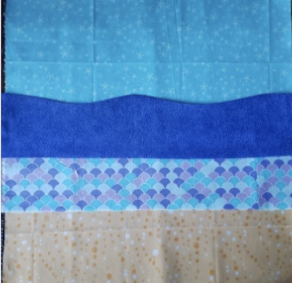

Classes 2 and 3– Work on Applique Design

Use fabrics supplied and also FREE SEW box to make applique design on front of bag.
- Think of the background first and add strips of fabric for sand, ocean and sky (if using the beach theme). Either:
  - Turn under the edges and straight stitch
  - Zigzag the raw edges

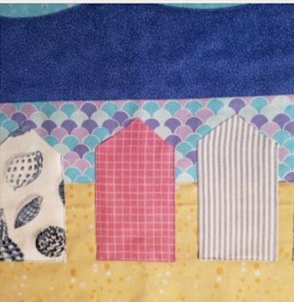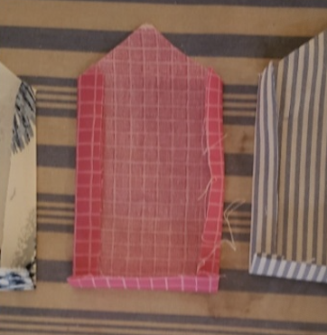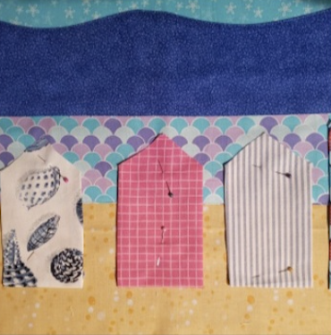

- Next add the main design, in this case the beach huts
- Fill in the details, for examples the boats, birds, kite, sun and clouds
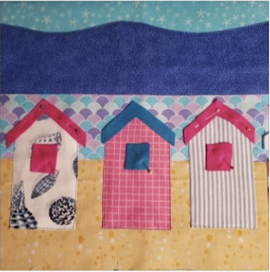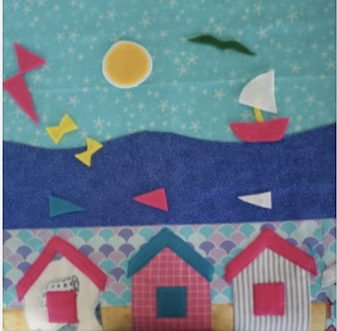
Class 4 - Decorate Back of Bag
Only advanced students should add zipper (see separate instructions)

Ideas -
Patch Pocket
Felt Lettering
Butterflies cut out of a patterned fabric and appliqued in place using a tight zigzag stitch

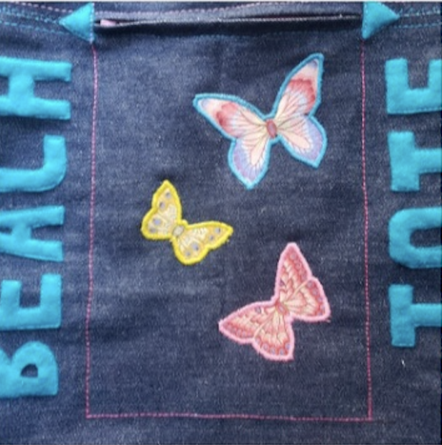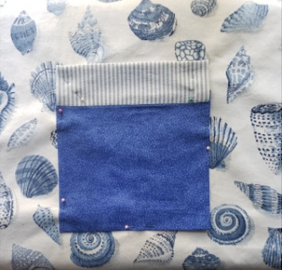

Class 5 - Sew Bag Front To Back & Add Box Bottom
(Optional - the box bottom can be skipped if student is behind)

- With RST pin bag front to bag back.
- Straight stitch around 3 edges leaving the top edge unstitched.

Box Corners -

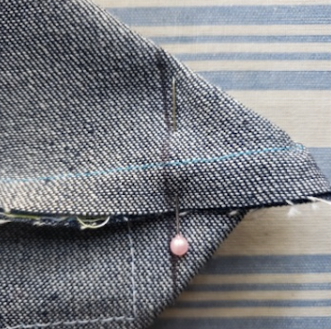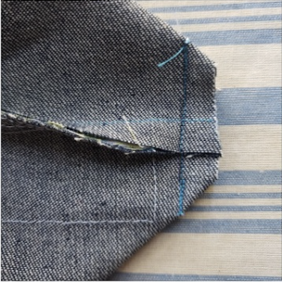
  - Measure 2 ½” from corner and draw a line.
  - Straight stitch along the marked line.
  - Trim the extra fabric off.
  - Repeat this process for other bottom corner.

Class 6 - Lining

- With RST pin lining front to lining back.
- Straight stitch around 3 edges leaving the top edge unstitched. LEAVE A 3” OPENING AT BOTTOM EDGE FOR TURNING
Box Corners - do the same as outer bag

Class 7 – Stitch Lining To Main Bag

- Turn main bag inside out and insert lining so that Right Sides are Together (RST).
- Match top edges of main bag and lining.
- Pin and stitch

- Turn to right side, pulling main bag through opening left in lining
- Iron
- On right side of bag topstitch around top edge. Stitch a second row of top stitching
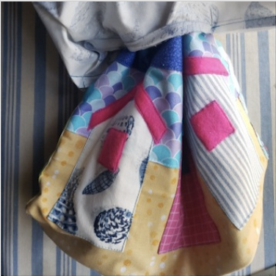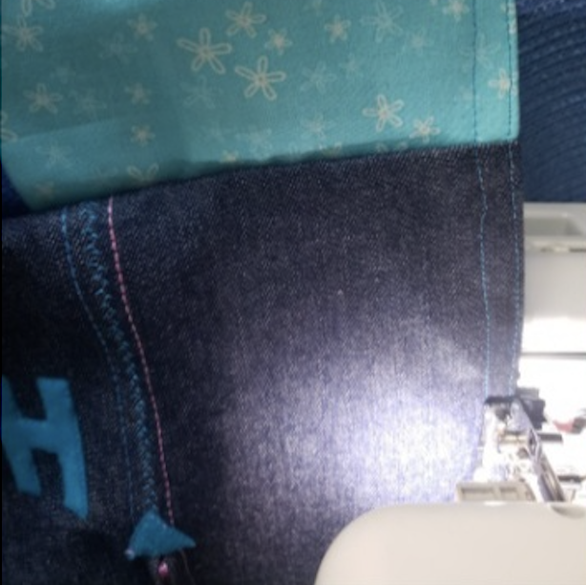

Class 8 - Straps

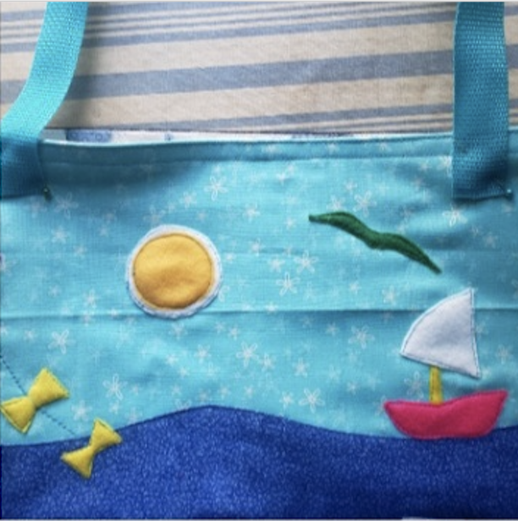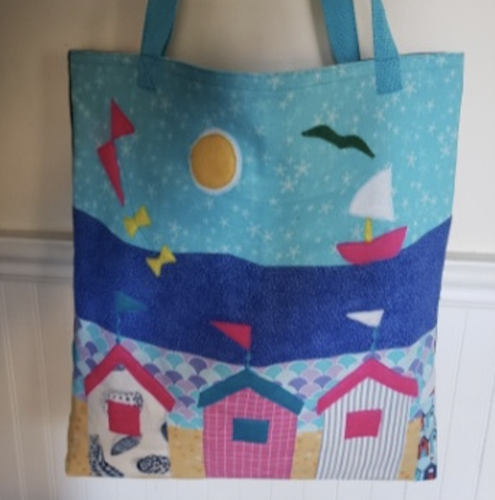

Pin and stitch straps in place.
The Beach Tote Bag is complete, congratulations!

