Beginner Sewing Machine & Hand Sewing Combo
Lesson 5

 | Today’s Sewing Machine Project | Pocket Pouch (may be a different design)  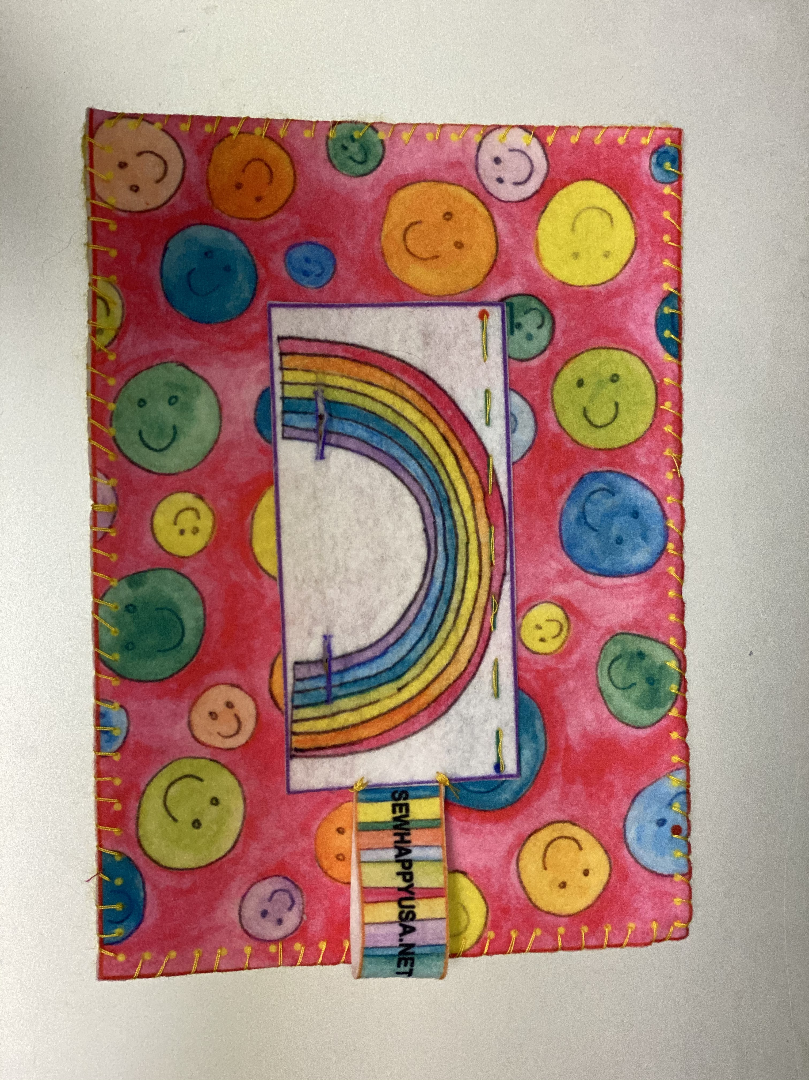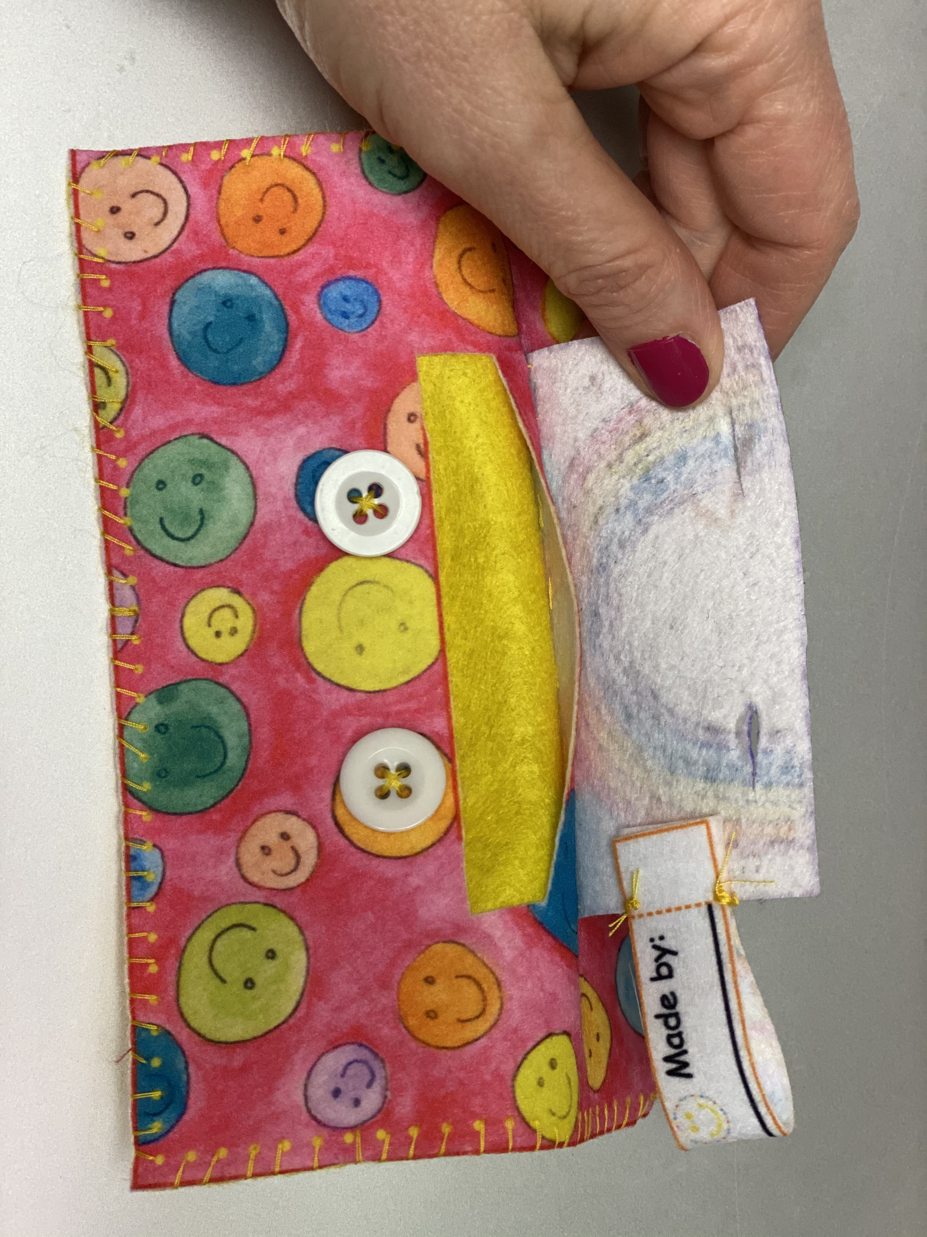
 | Today’s Hand Sewing Project | Keychain  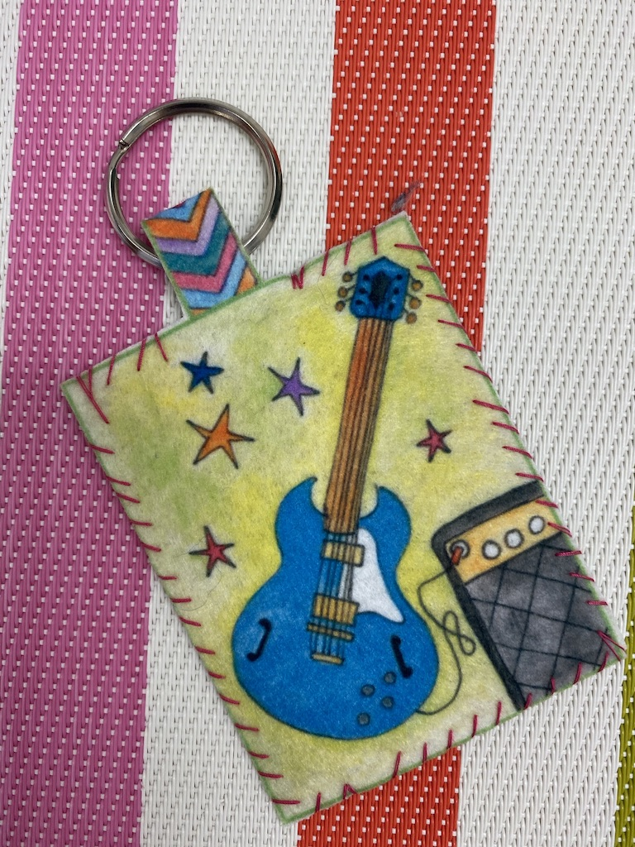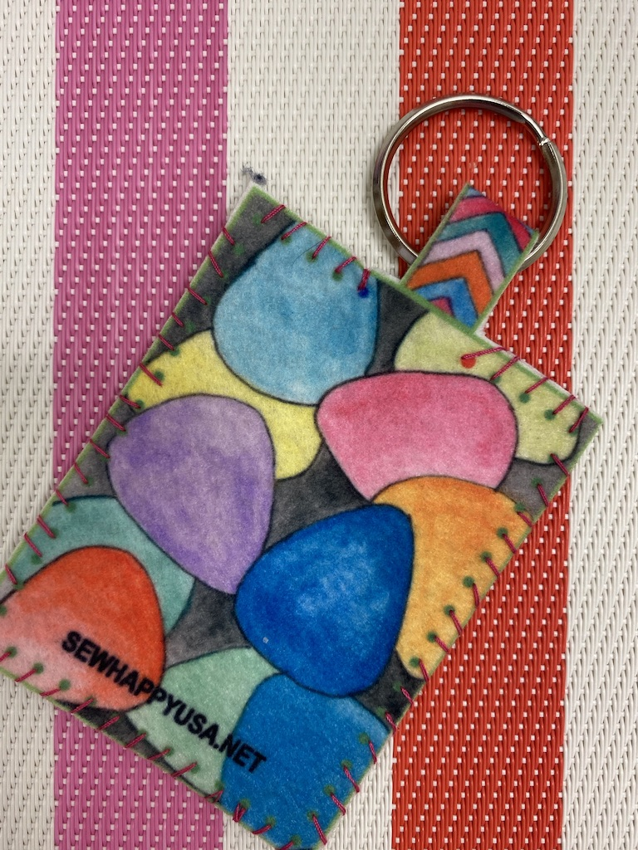
 | Today’s New Skills | Practice threading machine and inserting bobbin
 | Extra Materials Needed | - Pocket Pouch  - Keychain  - Key Ring
10 mins | Start of Class | - Sew Happy Way (See Instructor Binder)  - Goals For Today “To make a pocket pouch using the sewing machine, to sew buttons on the pouch and to hand sew a keychain.”
5 Mins | Refresher | Basic Anatomy of Sewing Machine:  - On/Off Switch  - Bobbin  - Thread  - Needle  - Presser Foot  - Hand/Fly Wheel  - Presser Foot Level

15 Mins | Refresher | Threading the machine, winding and inserting a bobbin:  - Have the students practice
20 Mins | Machine Sewing | - Sew The Flap To The Pocket Pouch Front:  - Cut the pouch and flap  - Pin flap to pocket pouch front (lining up with markings)  - Stitch in place making sure to do 3 back stitches at the beginning and end  HAND SEW THE BUTTONS IN PLACE AT THE “X’s”  - Sew The Pocket Pouch Front To Back:  - With wrong sides together pin the pouch front to pouch back  - Sew around stitch lines (dots)  - Cut buttonholes (an instructor should help with this)  - Optional: Add a made-by label
30 Mins | Hand Sewing | Keychain:  - Cut the keychain carefully making sure not to cut the fabric that holds the front to the back  - Roll fabric and insert through key ring so that the key ring is hanging on the middle piece of fabric  - Match the front of the keychain to the back and pin in place  - Using a whipstitch, sew all around the keychain following the dotted stitch line.
10 Mins | End Of Class | Clean-up & Dismissal

