After School Club Instructor’s Lesson Plan

Cat Apron

Materials:

2 x 14” x 18” Pieces of cotton for main apron
4 x pocket pieces
8 x ear pieces
2 x hearts for nose
4 x buttons for eyes
1 x 72” twill tape (1 ¼”)
Embroidery floss and hand sewing needles

- Pockets – with RST pin and sew around two sides, leaving the top open (1/4 - ½” seam)

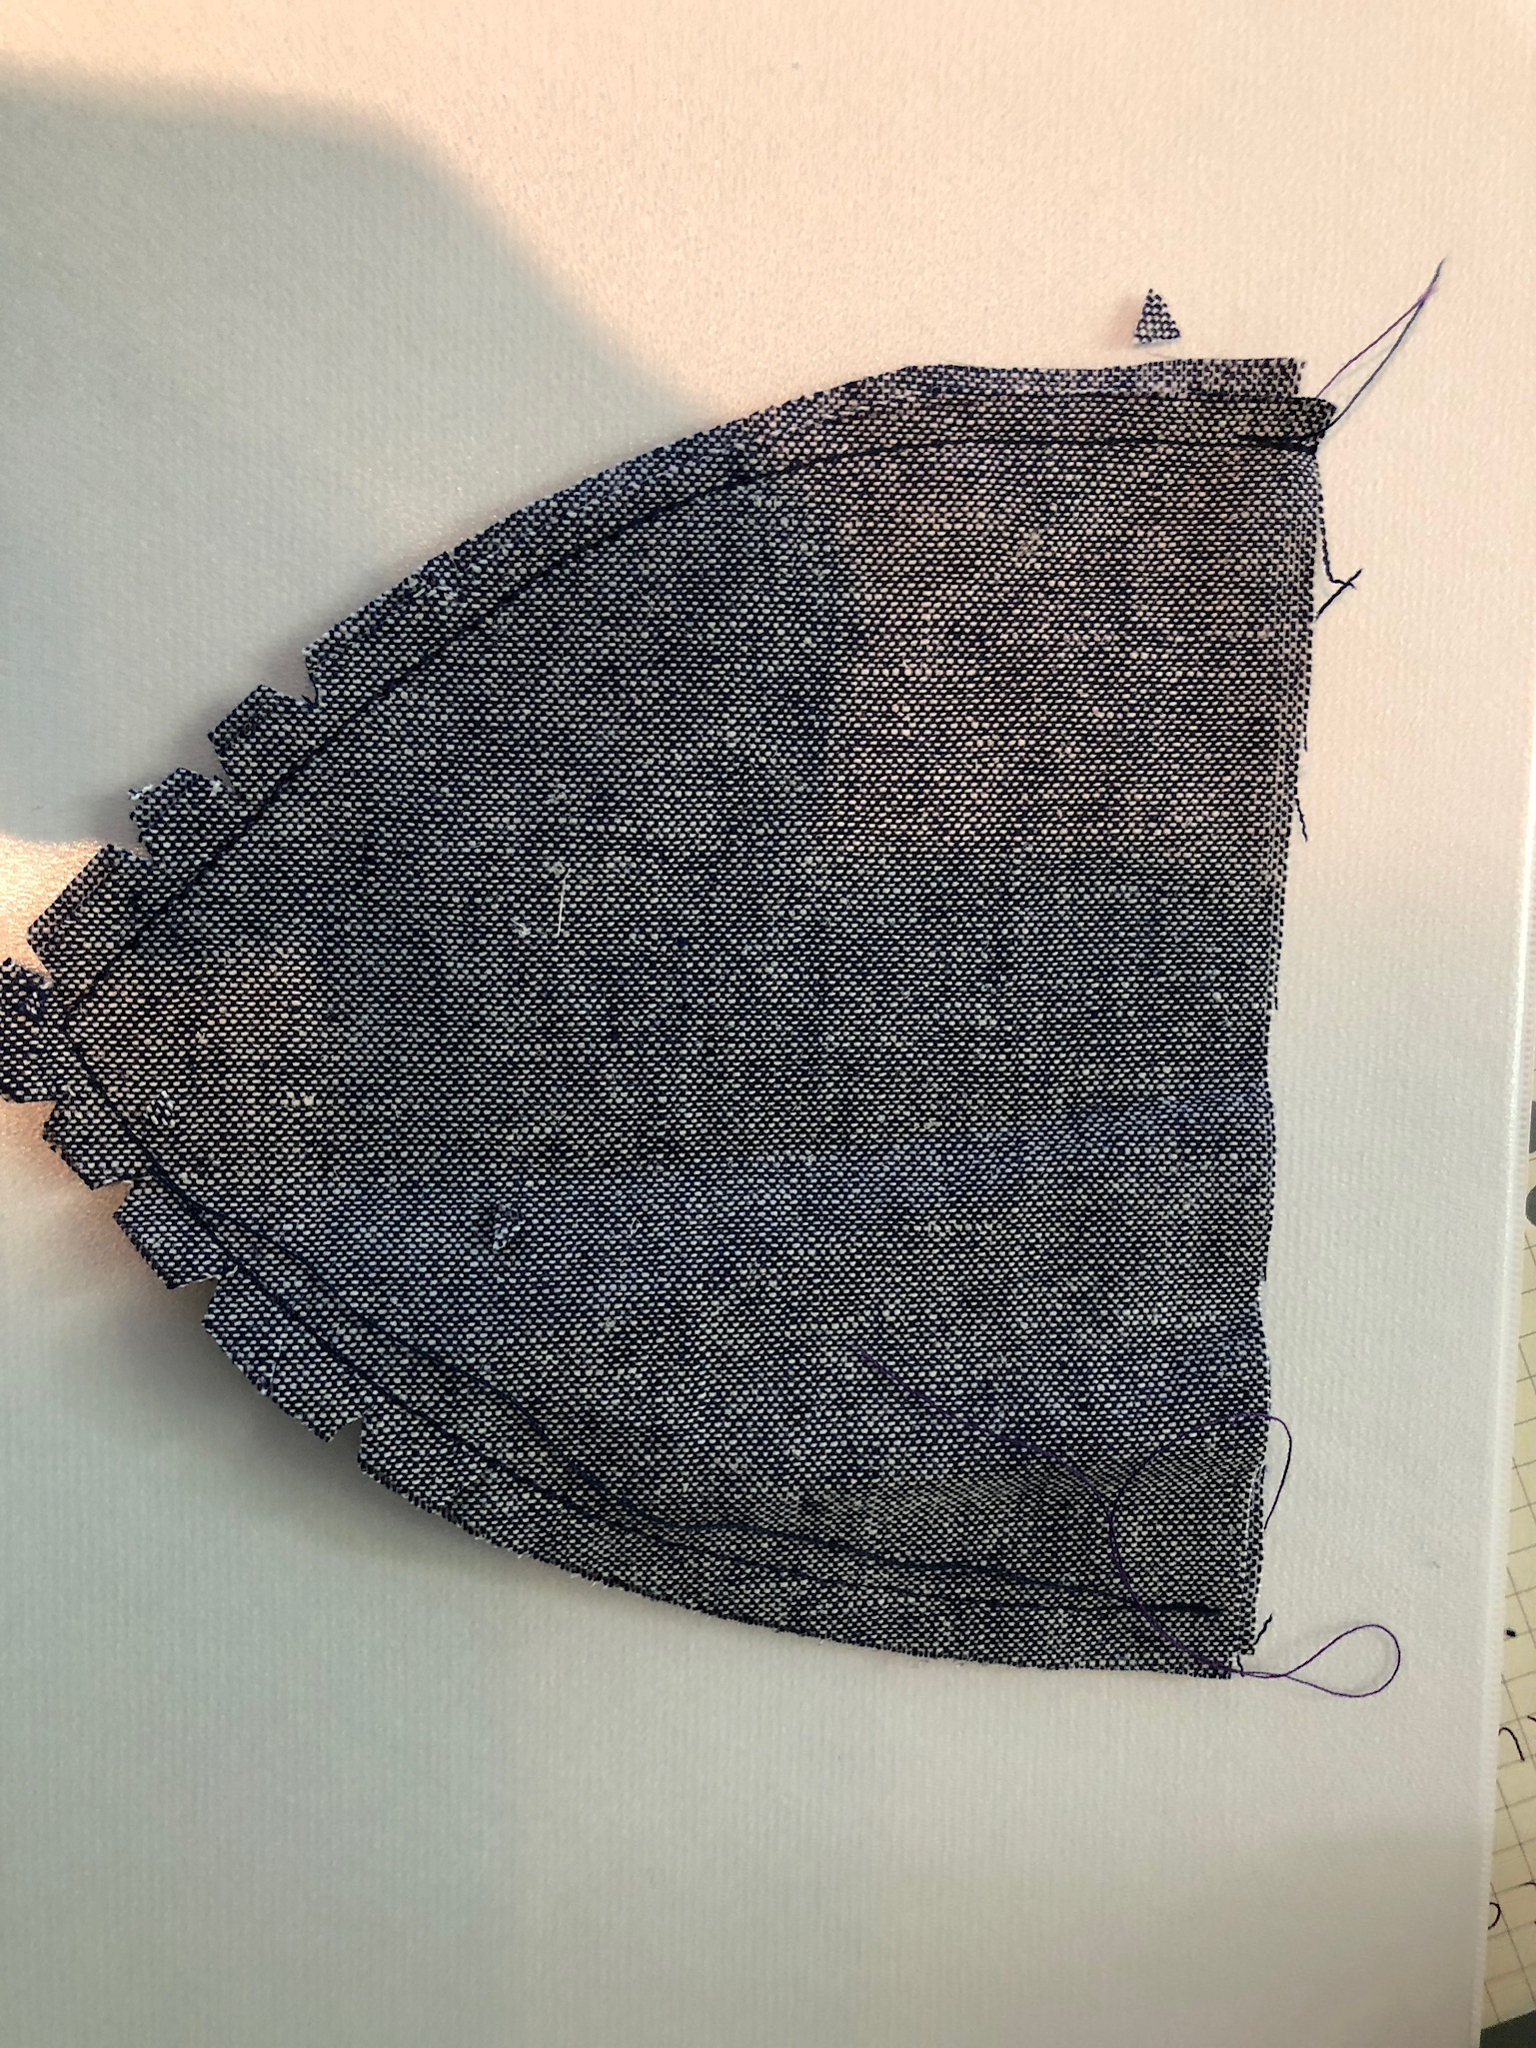

- Clip curves
- Flip to right side
- Iron flat
- Turn in top edge and iron (1/4 – ½”)
- Hand stitch nose, mouth and eyes
- Ears - with RST pin and sew around two sides, leaving the top open (1/4 - ½” seam)

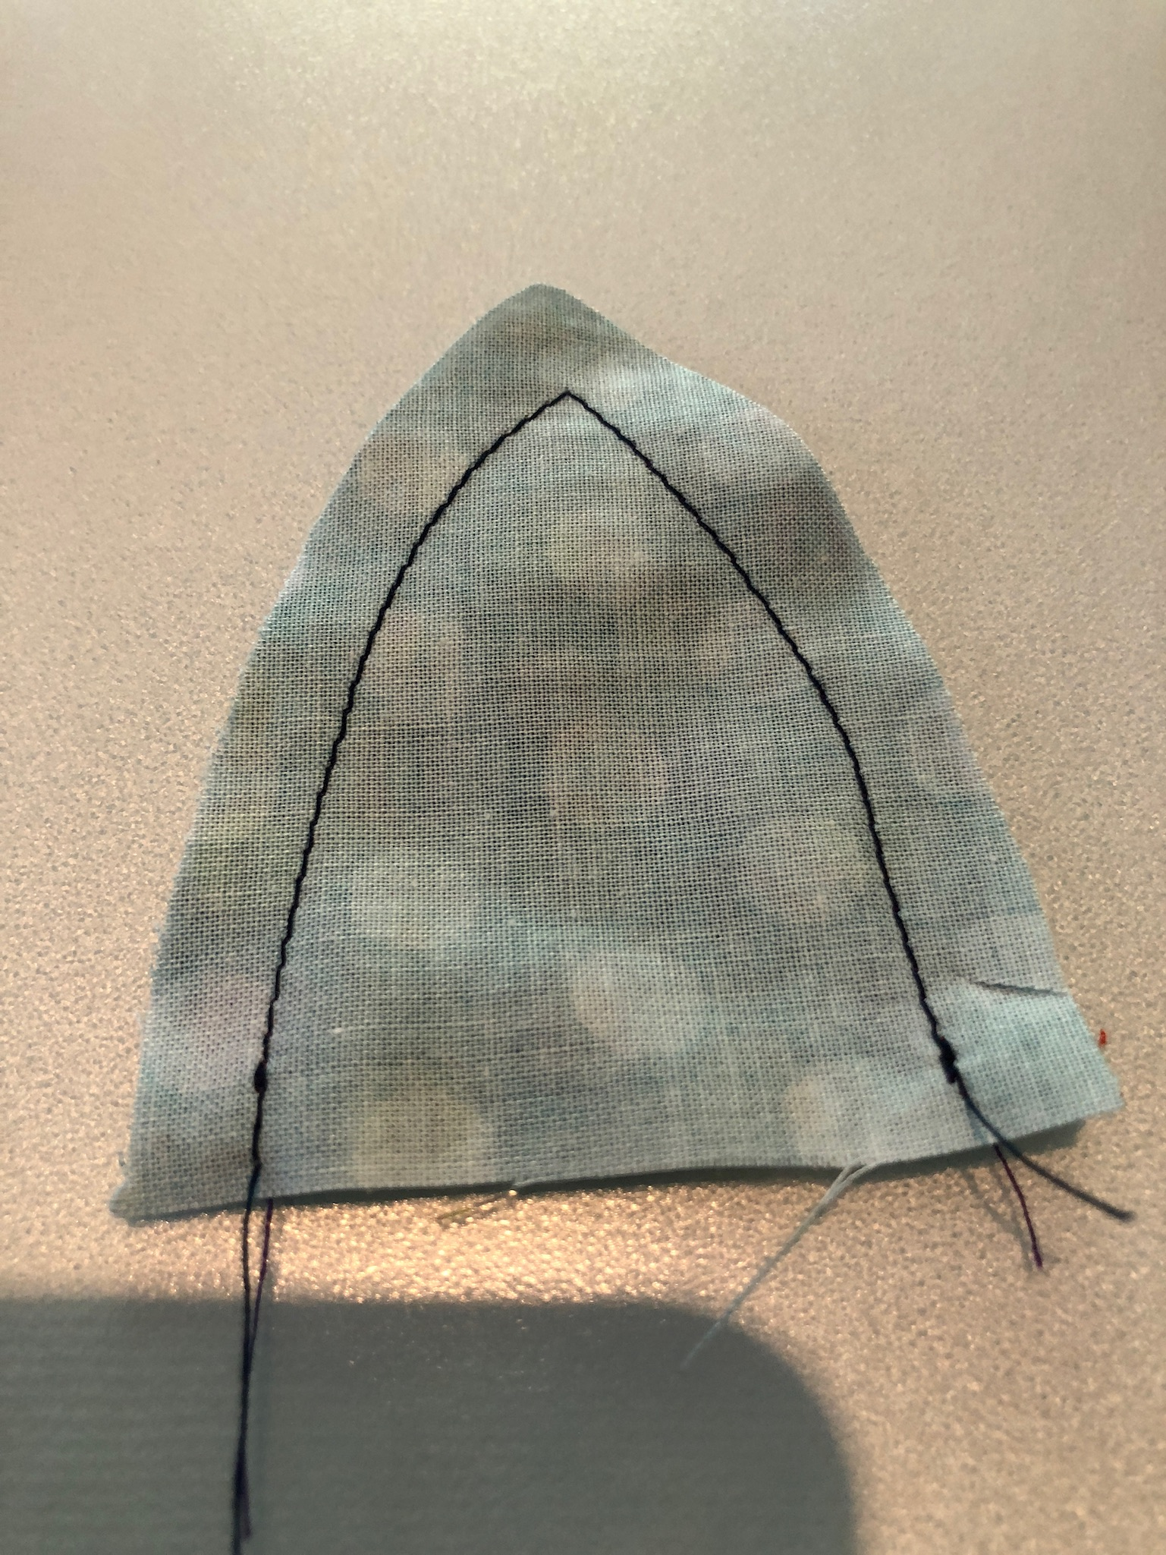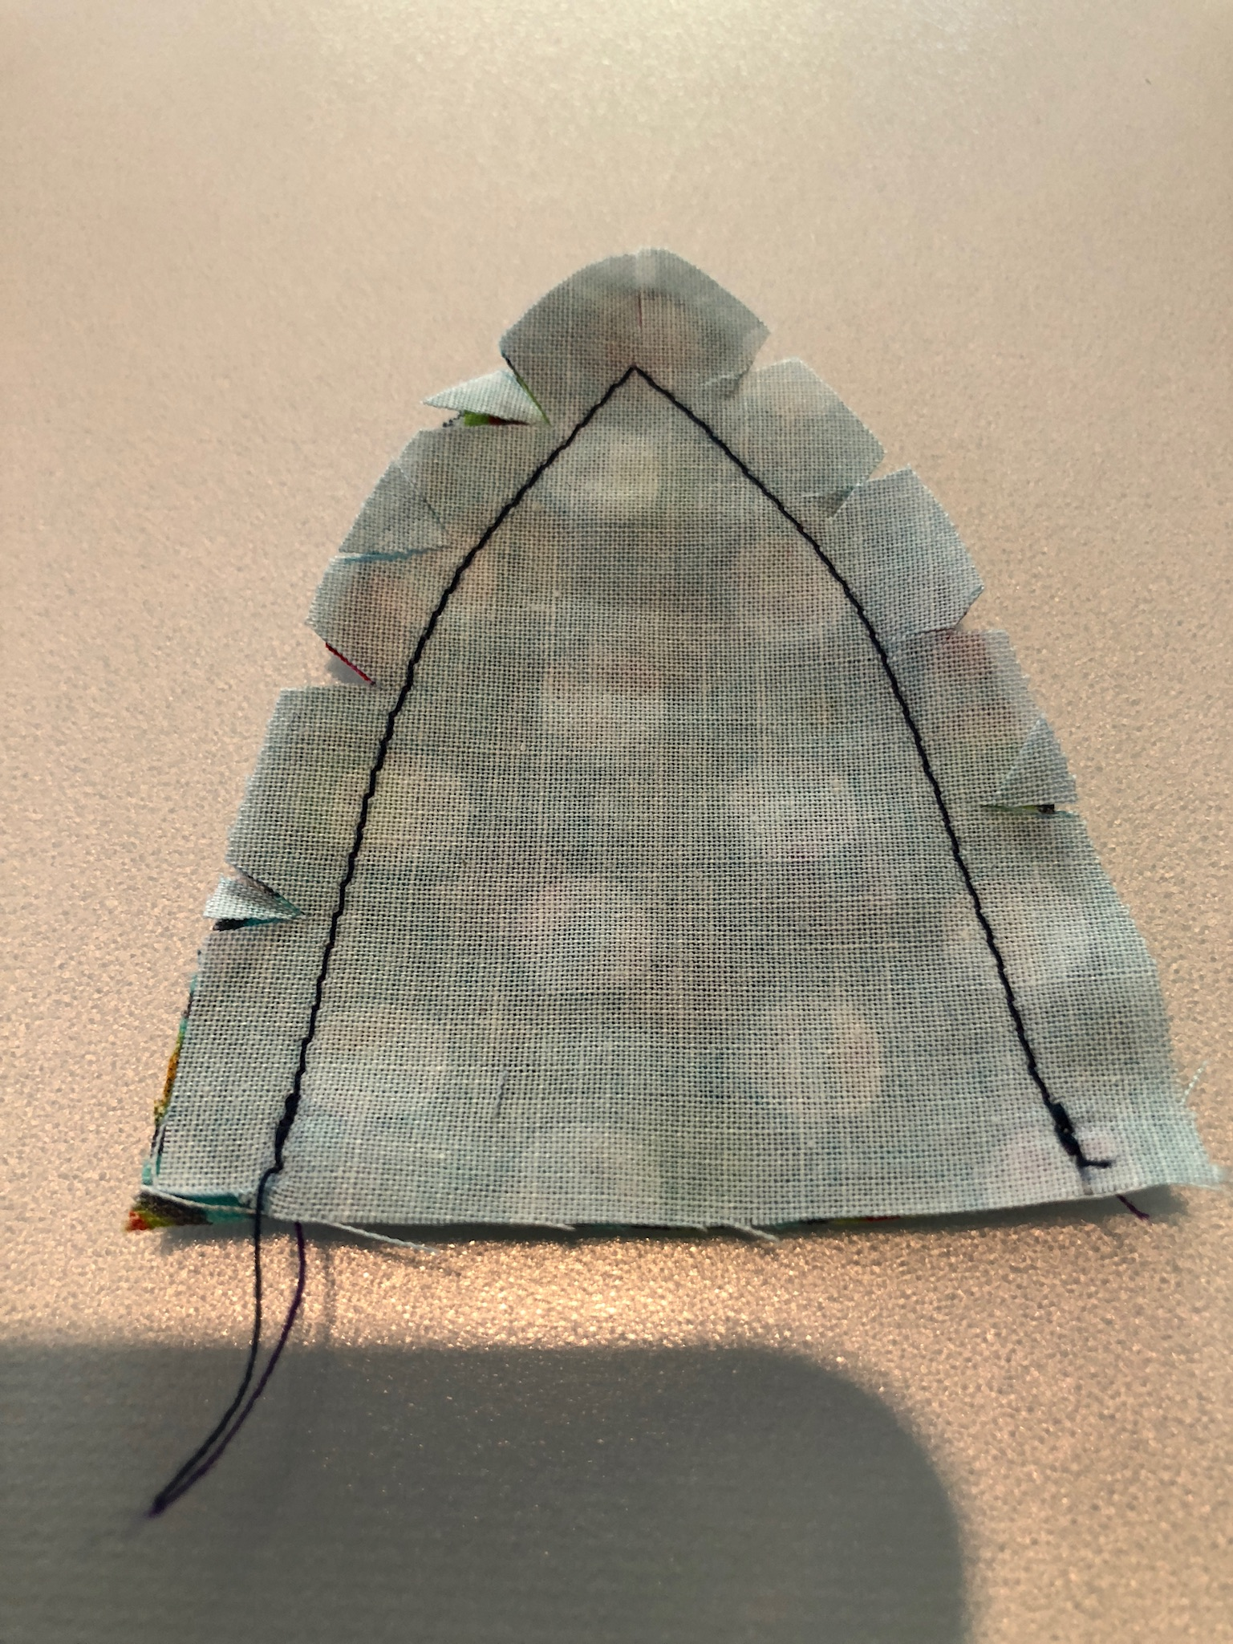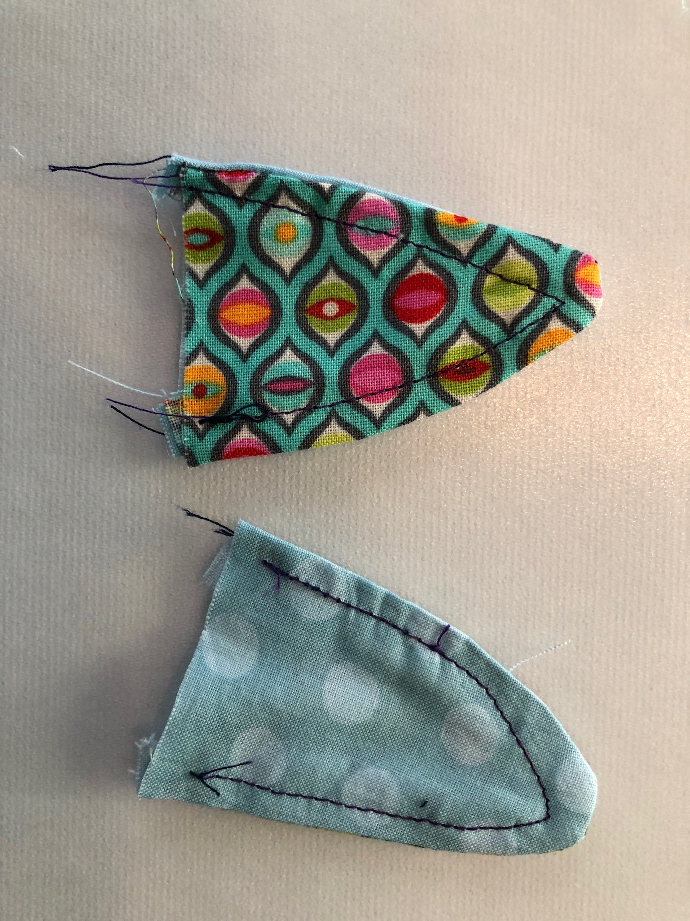

- Clip curves
- Flip to right side
- Iron flat

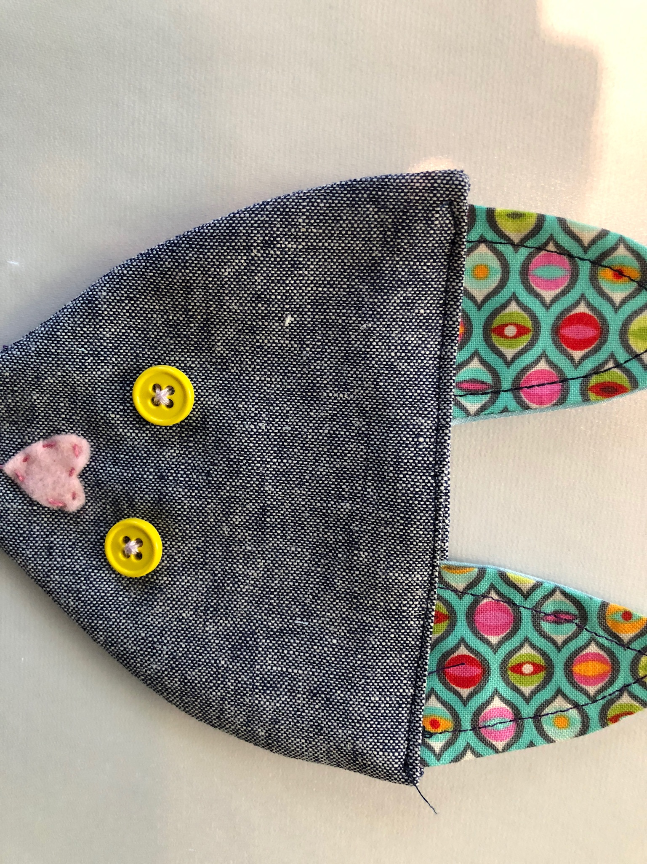

- Insert ears in to top of pocket
- Pin in place and stitch along top edge of pocket
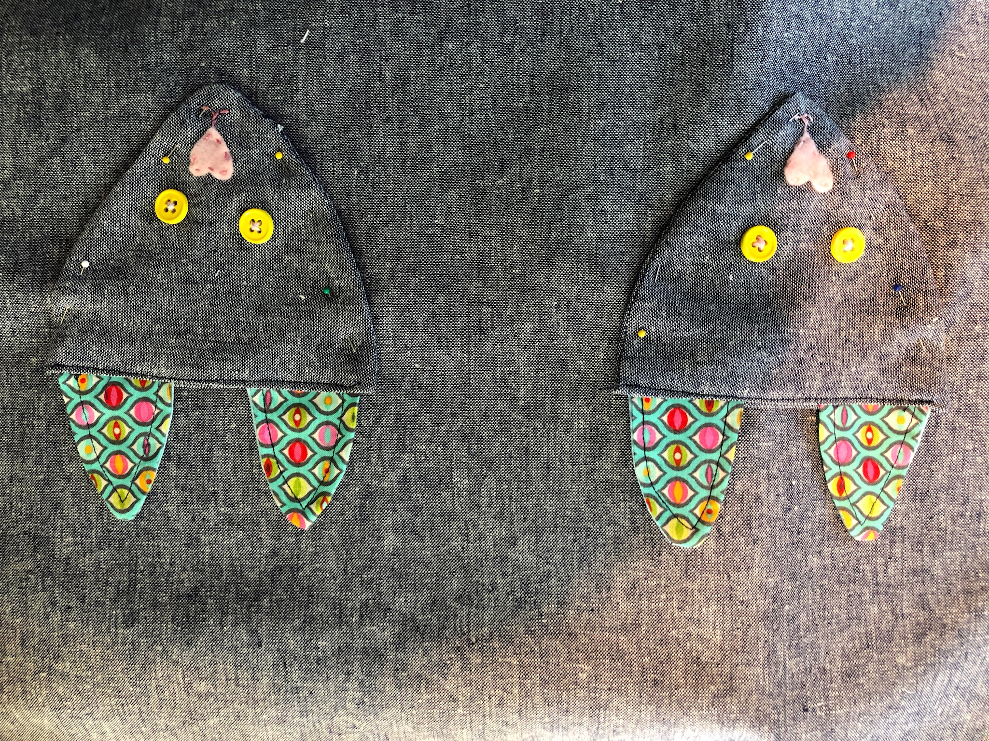

- Pin pockets on apron
- Stitch sides, leaving top open
- Hand stitch whiskers
- Apron – With RST pin apron main pieces together (1/2” seam)
- Stitch leaving a 6” gap at top edge for turning
- Clip corners
- Flip to right side
- Iron
- Top stitch around sides and bottom

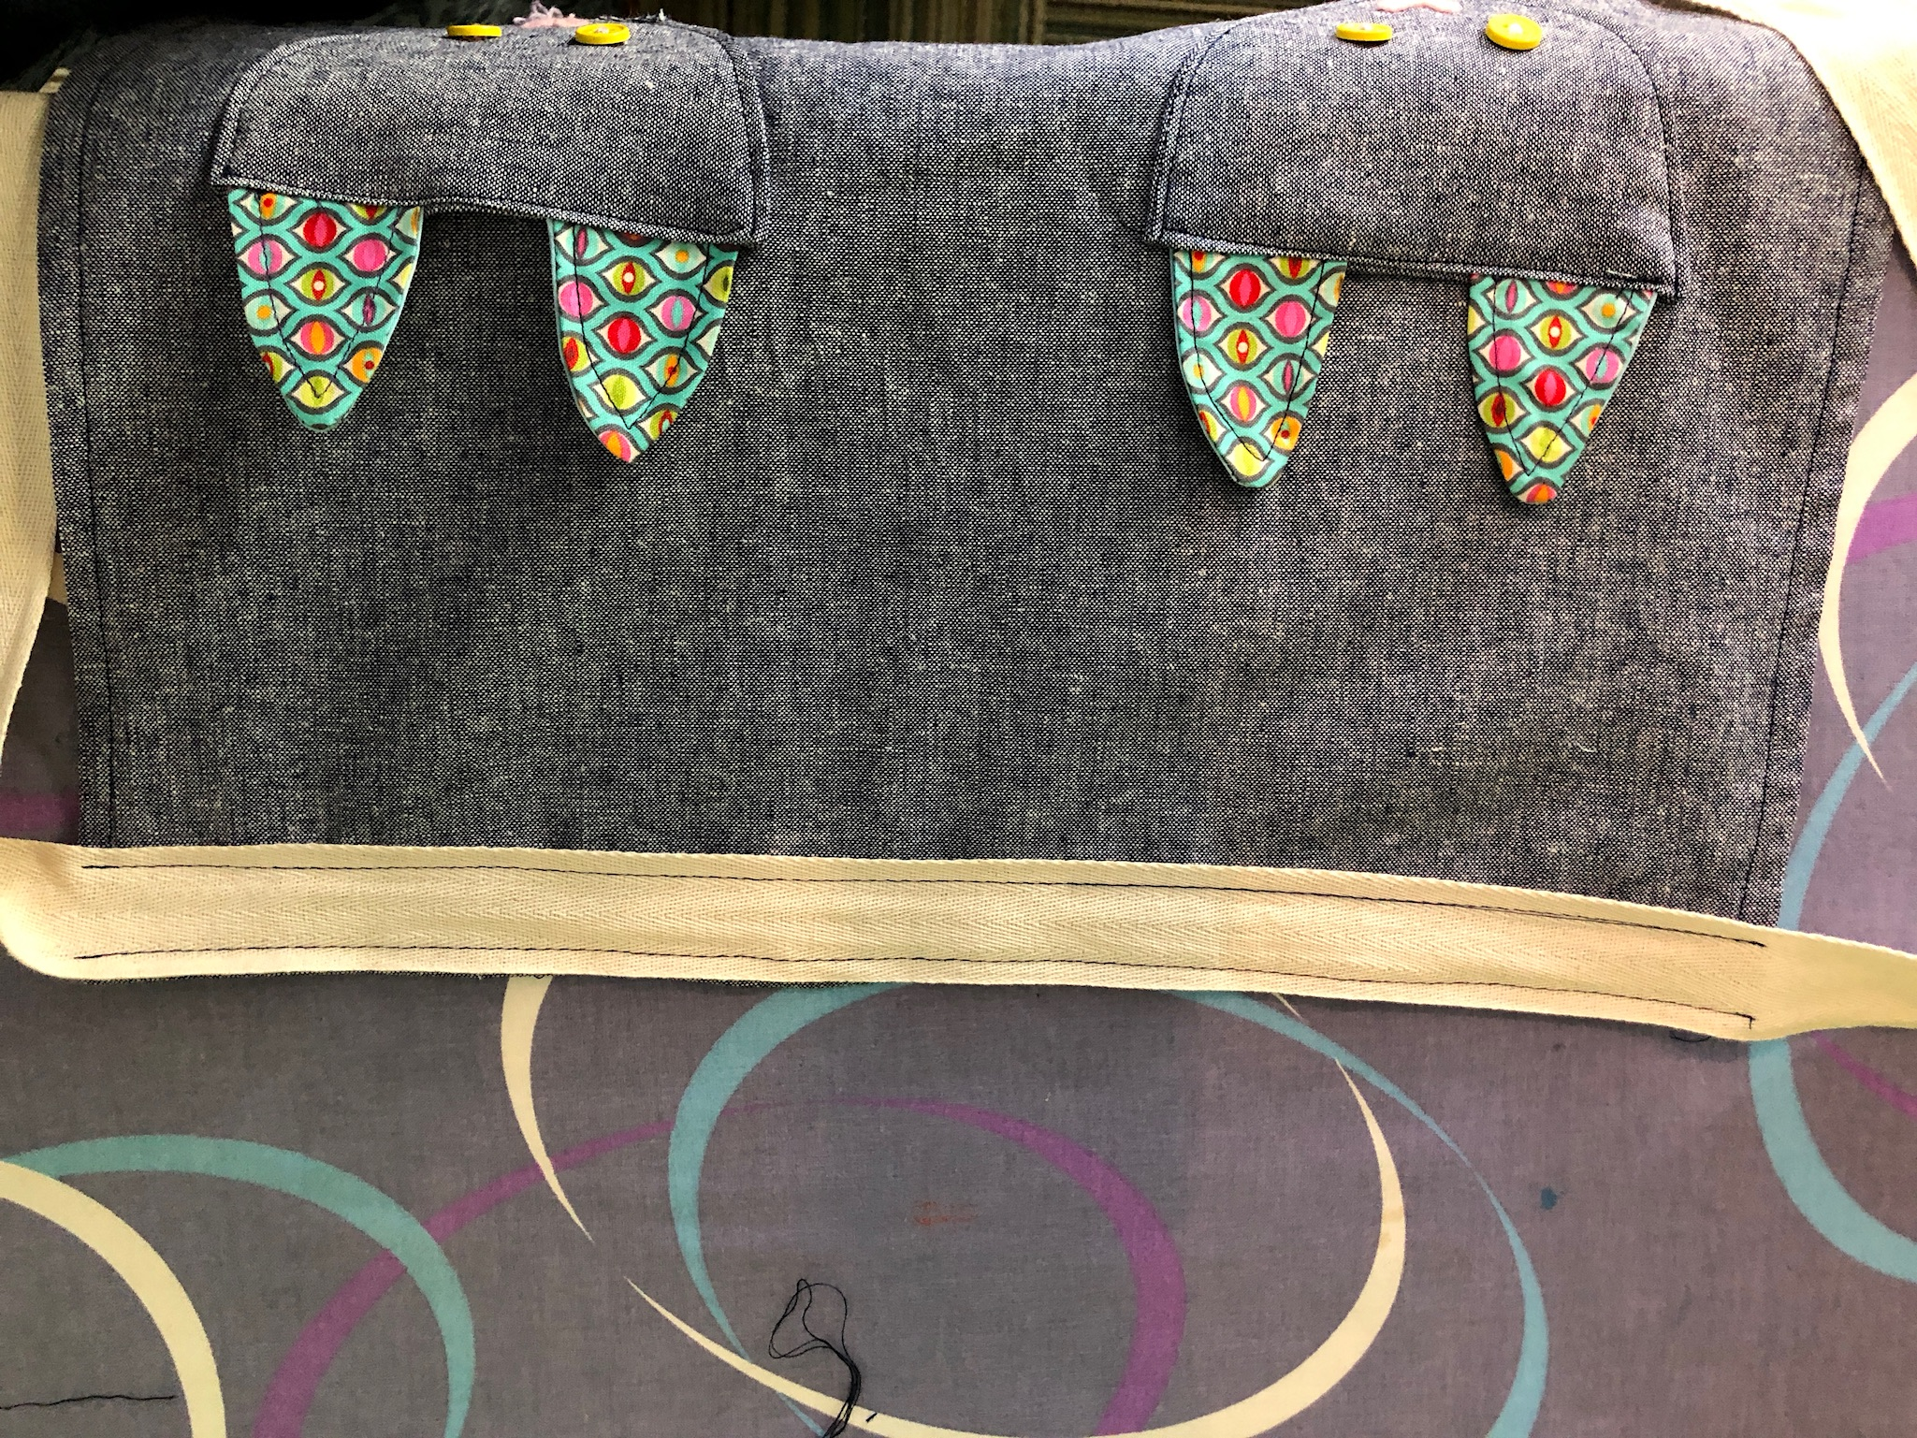

- Center twill tape on top edge of apron and pin in place
- Stitch
- Hem ends of twill tape

You are finished!

