LLAMA DRAMA

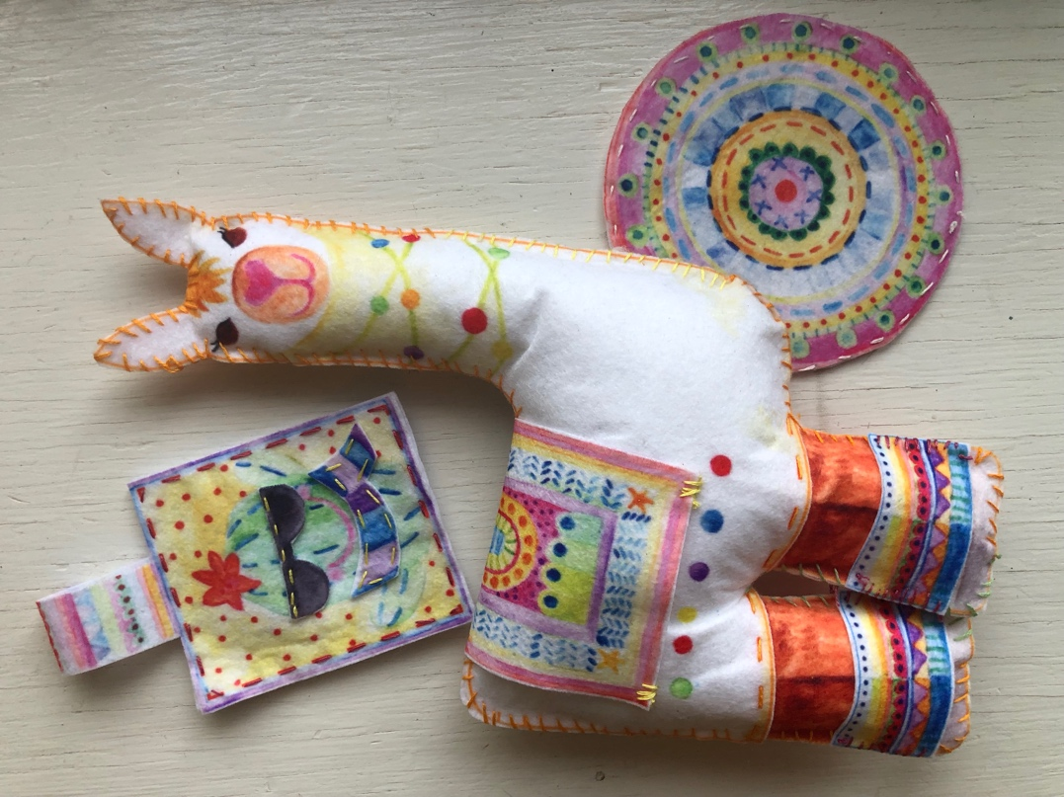

INSTRUCTOR PREPARATION

- CUT:  MUG RUG BACK (This is practice piece)  - THREAD and KNOT one needle per student | 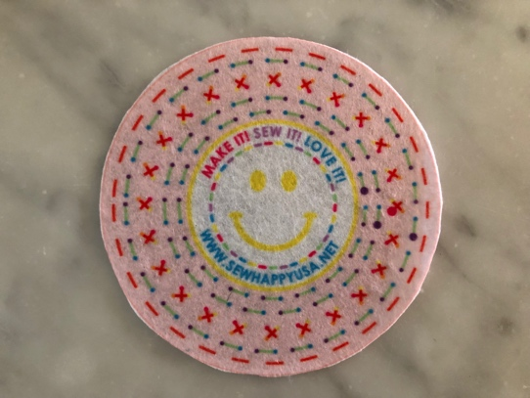
REMINDERS & DEMONSTRATIONS

Refer To “First Class” in The Sew Happy Instructor Training (Can Be Found In Instructor Binder)

WEEK 1
WEEK 1 SEWING STEPS

1. | Introduction & Demo  SEE SEPARATE NOTES FOR WEEK 1
2. | The Practice Piece today is:  - Mug Rug Back
3. | Starting at the LARGE PURPLE DOT close to the edge of the circle, insert needle in the back of the fabric and pull the needle all the way through.  Insert needle in small blue dot and pull until the thread is all the way through. Repeat this “STAB STITCH” method and sew along the GREEN STITCH LINES until you get back to where you started.  On the back of the MUG RUG, make a LOCK STITCH (by leaving a small loop and pulling needle through the loop).  Cut thread close to LOCK STITCH.  Students should now take a new piece of floss and try to thread their needles. Start another row of stitches beginning at one of the other LARGE PURPLE DOTS. | 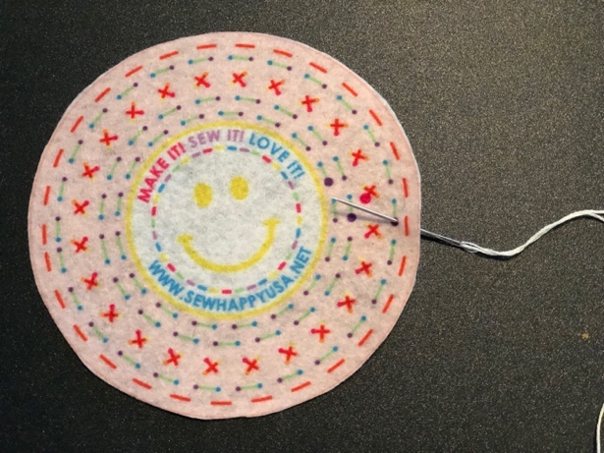

TIP! | STAB STITCH: Insert the needle in to the fabric and pull all the way through. Once a student has mastered the STAB STITCH, he/she can start to do the RUNNING STITCH where the needle is inserted in to the fabric and out again in one motion.
*EXTRA WORK* | Extra activities for students who finish early:  Add more stitching to MUG RUG BACK  Do NOT allow any student to move on to the next step! | 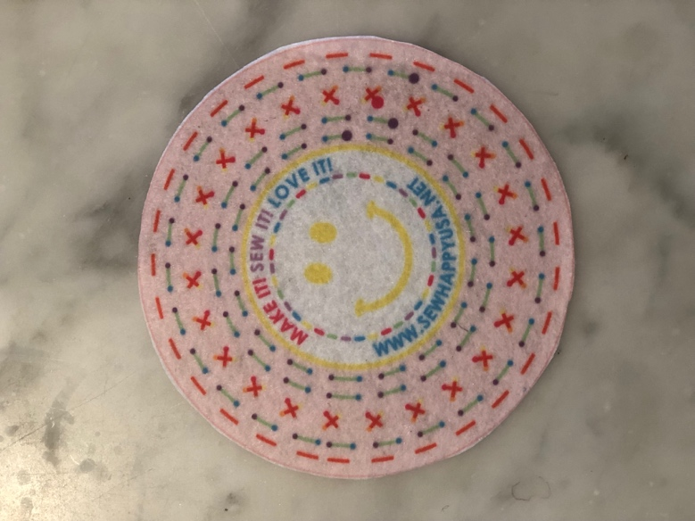

WEEK 2
INSTRUCTOR PREPARATION

- CUT:  MUG RUG FRONT  - THREAD and KNOT one needle per student. | 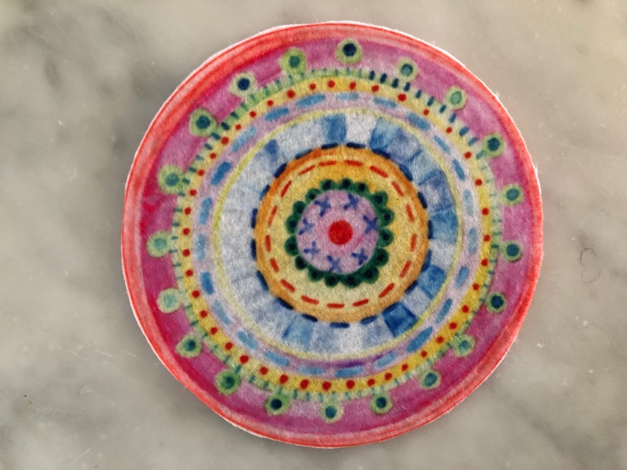
REMINDERS & DEMONSTRATIONS

- Weekly Meeting & Classroom Rules  - DEMO threading a needle using the needle threader and pincushion technique.  This week the demo and practice SHOULD TAKE 15-20 MINUTES | - Give each student a pincushion, needle and needle threader and have them practice threading the needle and tying a knot around the needle.  - REMIND students about LOCK STITCH

WEEK 2 SEWING STEPS

1. | Reminders & Demo  DO NOT SKIP THIS STEP! | (See Previous Page)
2. | Hand each student:  Practice Piece from last week (in student Ziploc bags)  Pre-threaded needle if they didn’t thread their own
3. | Continuing from last week, complete the GREEN stitch lines.  NOTE: Do NOT stitch the RED straight stitches around the edge of the mug rug as these are for sewing the front to the back of the mug rug. | 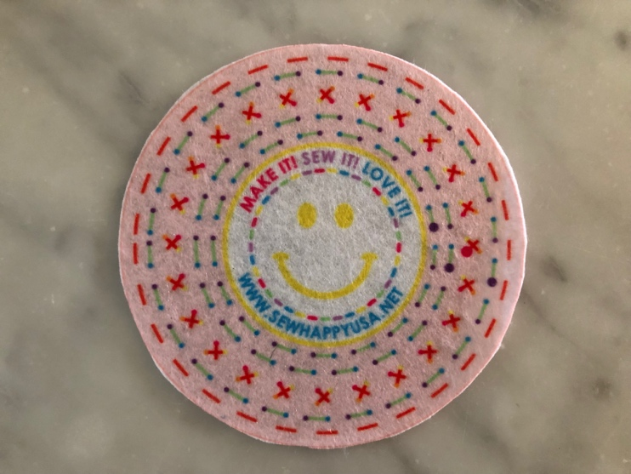
TIP! | As a student finishes their thread they can try to thread their own needle using the pincushion and needle threader technique.
*EXTRA WORK* | Extra activities for students who finish early:  Work on CROSS STITCHES on mug rug.  Add decorative stitches to MUG RUG FRONT (Note: there are no specific stitch lines to follow but the students can embellish as they wish) | 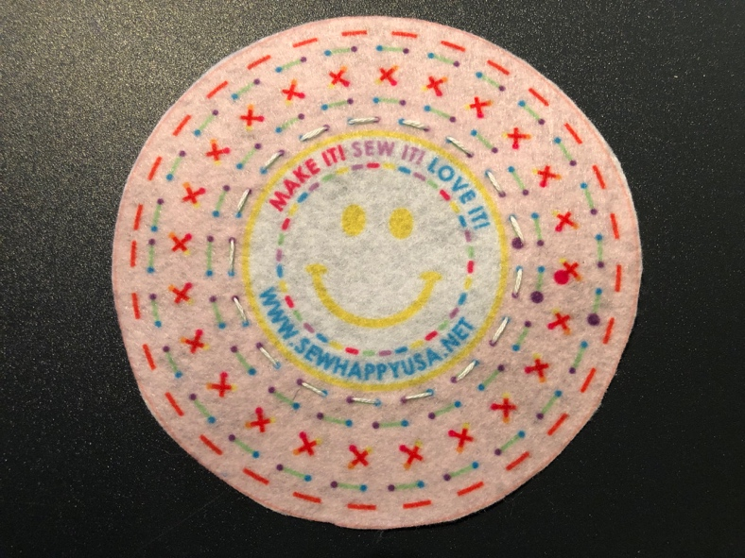  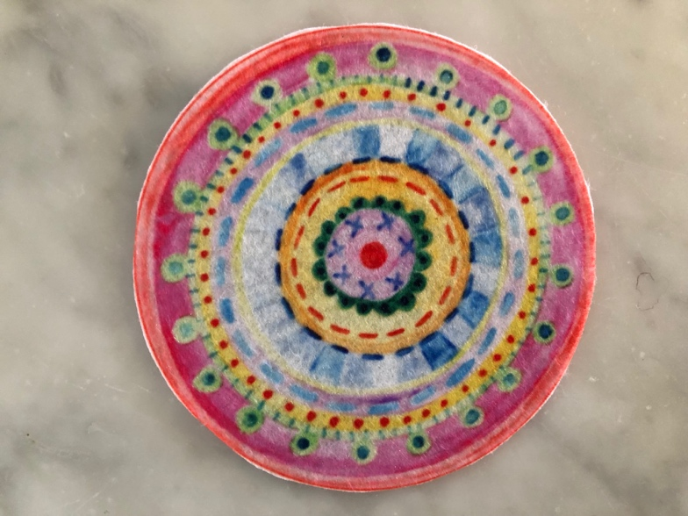  Do NOT allow any student to move on to the next step!

INSTRUCTOR PREPARATION

- CUT:  - LLAMA FRONT  - LLAMA BACK  - LLAMA LEGS x 4  - THREAD and KNOT one needle per student. | 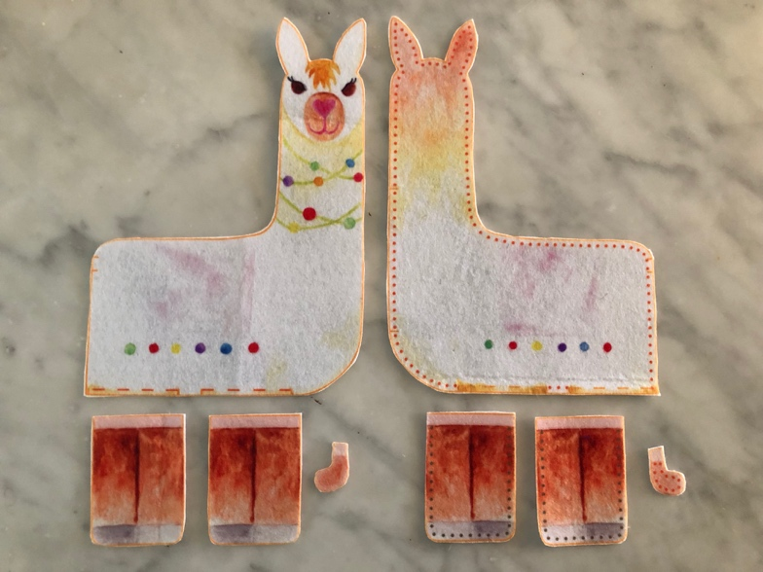
REMINDERS & DEMONSTRATIONS | NOTE: Please do not use the tails (included in the earlier design). Please use the crochet hook to pull out some stuffing instead. This will be the tail.
- Weekly Meeting & Classroom Rules  - DEMO threading a needle using the needle threader and pincushion technique.  This week the demo and practice SHOULD TAKE 15 MINUTES | - PRACTICE - Give each student a pincushion, needle and needle threader and have them practice threading the needle and tying a knot around the needle.  - REMIND students about LOCK STITCH
WEEK 3

WEEK 3 SEWING STEPS

1. | Reminders & Demo  DO NOT SKIP THIS STEP! | (See Previous Page)
2. | - PIN FRONT LEGS underneath LLAMA FRONT matching edges of legs to the stitch markings on LLAMA FRONT.  - Stitch.  - Finish with a LOCK STITCH.  - PIN BACK LEGS (with dotted stitch lines) underneath LLAMA BACK (with dotted stitch lines), matching edges of legs to the stitch markings on LLAMA BACK.  - Stitch.  - Finish with a LOCK STITCH. | 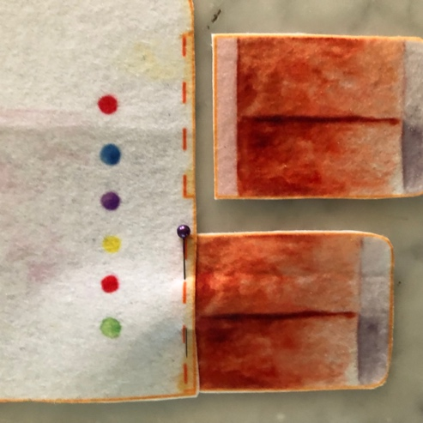  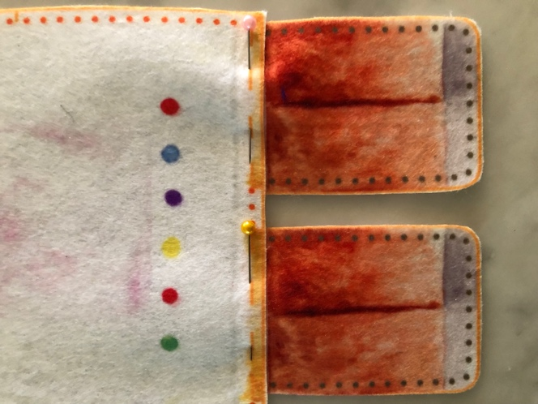

TIP! | - Remind students to stop when their thread gets to 4” long so they can do a LOCK STITCH and start a new thread. | Use the laminated rulers in your instructor bin.
*EXTRA WORK* | Extra activities for students who finish early:  Add stitching to MUG RUG FRONT | 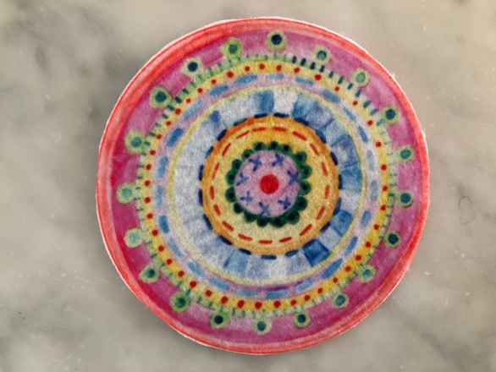  Do NOT allow any student to move on to the next step!

WEEK 4
INSTRUCTOR PREPARATION

- THREAD and KNOT one needle per student.

REMINDERS & DEMONSTRATIONS

- Weekly Meeting & Classroom Rules  - DEMO threading a needle using the needle threader and pincushion technique.  This week the demo and practice SHOULD TAKE 15 MINUTES | - PRACTICE - Give each student a pincushion, needle and needle threader and have them practice threading the needle and tying a knot around the needle.  - REMIND students about LOCK STITCH

WEEK 4 SEWING STEPS

1. | Reminders & Demo  DO NOT SKIP THIS STEP! | (See Previous Page)
2. | Hand each student:  Llama FRONT & BACK
3. | PIN llama FRONT to llama BACK. Show students where the 2 lines along the neck edge of the llama mark the opening for inserting the stuffing next week.  Starting at one of these lines, start stitching around the llama using a WHIP STITCH, making sure to insert the needle in each DOT.  WHIP STITCH – insert needle through dot on the back of llama that is next to the neck edge mark line. Pull thread all the way through. Repeat moving to the next DOT each time. | 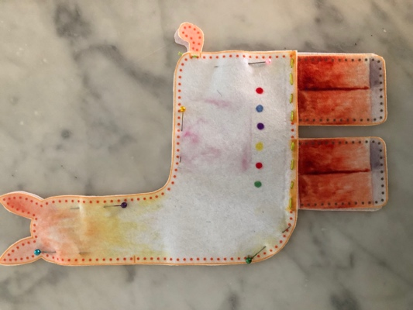  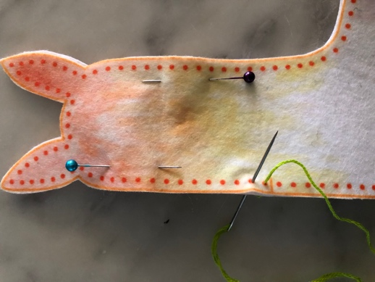
TIP! | As a student finishes their thread they can try to thread their own needle using the pincushion and needle threader technique.
*EXTRA WORK* | Extra activities for students who finish early:  Add more stitching to MUG RUG FRONT or BACK. There are plenty of places for the students to embellish so suggest they get creative. | Do NOT allow any student to move on to the next step!

INSTRUCTOR PREPARATION

- CHECK:
In each student’s bag and catch up anyone who can’t move forward to next week’s steps

- THREAD and KNOT one needle per student.

REMINDERS & DEMONSTRATIONS

- Welcome Meeting & Classroom Rules  - REFRESHER - threading a needle using the needle threader and pincushion technique.  - REFRESHER - TYING A KNOT and LOCK STITCH  This week the demo and practice SHOULD TAKE 10 MINUTES | - Practice - Give each student a pincushion, needle and needle threader and have them practice threading the needle, tying a knot around the needle and tying a knot at the end of their thread.
WEEK 5

WEEK 5 SEWING STEPS
1. | Reminders & Demo  DO NOT SKIP THIS STEP!
2. | Hand each student:  - Llama (in student bags)
3. | - Students should continue stitching llama FRONT to llama BACK until they reach the second marking for the opening.  TIP – Remind students to stop when their floss gets to 4” long (use laminated rulers in instructor bin). They need to stop and make a LOCK STITCH  - STUFF llama, pushing small amounts of stuffing in to legs, head and ears.  TIP – a blunt end of a pencil may be used to gently push the stuffing in to these areas  - PIN and STITCH opening closed | 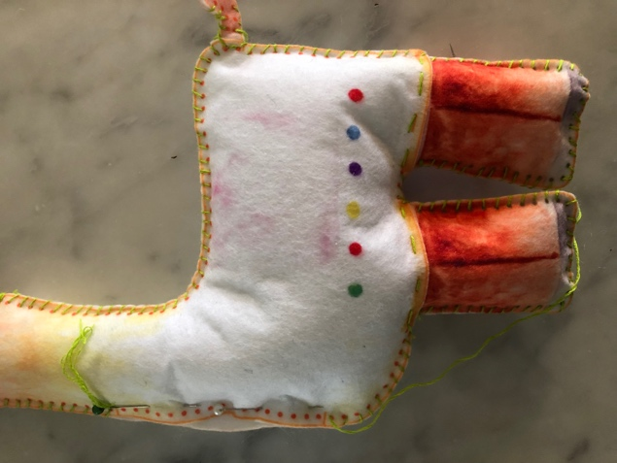
4. | TAIL - Insert crochet hook in between stitches to pull out a tiny bit of stuffing to make the tail.

*EXTRA WORK* | Extra activities for students who finish early:  Embellish MUG RUG further  Do NOT allow any student to move on to the next step!  DON’T ALLOW STUDENT TO TAKE LLAMA HOME YET AS THEY HAVE THE OPTION NEXT WEEK TO SEW THE LEGWARMERS ON!

INSTRUCTOR PREPARATION

- CUT: BLANKET  - CHECK:  In each student’s bag and catch up anyone who can’t move forward to next week’s steps  - THREAD and KNOT one needle per student. | 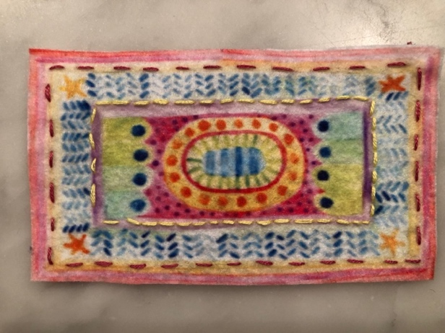
REMINDERS & DEMONSTRATIONS

- Welcome Meeting & Classroom Rules  - REFRESHER - threading a needle using the needle threader and pincushion technique.  - REFRESHER - TYING A KNOT and LOCK STITCH  This week the demo and practice SHOULD TAKE 10 MINUTES | - Practice - Give each student a pincushion, needle and needle threader and have them practice threading the needle, tying a knot around the needle and tying a knot at the end of their thread.
WEEK 6

1. | Reminders & Demo  DO NOT SKIP THIS STEP!
2. | Hand each student:  - Llama (in student bags)  - Blanket
3. | - Embellish blanket with stitches. There are no stitch lines so encourage students to get creative!  - To STITCH BLANKET on to LLAMA, PIN BLANKET on LLAMA and stitch each corner with 3 overstitches. | 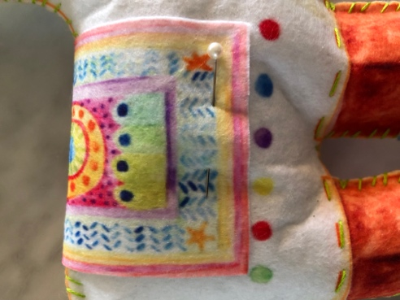
*EXTRA WORK* | Extra activities for students who finish early:  - Stitch blanket to llama around all 4 edges.  Do NOT allow any student to move on to the next step!  DON’T ALLOW STUDENT TO TAKE LLAMA HOME YET AS THEY HAVE THE OPTION NEXT WEEK TO SEW THE LEGWARMERS ON!

WEEK 7

INSTRUCTOR PREPARATION

- CUT:  - KEYCHAIN  - Piece of fabric with ACCESSORIES (DO NOT CUT individual accessories)  - CHECK:  In each student’s bag and catch up anyone who can’t move forward to next week’s steps  - THREAD and KNOT one needle per student. | 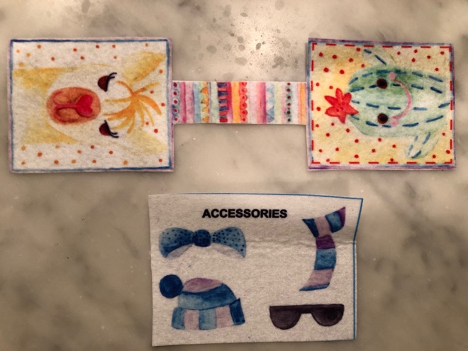
REMINDERS & DEMONSTRATIONS

- Welcome Meeting & Classroom Rules  - DEMO threading a needle using the needle threader and pincushion technique.  - DEMO TYING A KNOT and LOCK STITCH  This week the demo and practice SHOULD TAKE 5 MINUTES | - PRACTICE - Give each student a pincushion, needle and needle threader and have them practice threading the needle, tying a knot around the needle and tying a knot at the end of their thread.  - REMIND students about LOCK STITCH and KNOT.

WEEK 7 SEWING STEPS

1. | Reminders & Demo  DO NOT SKIP THIS STEP!
2. | Hand each student:  - KEYCHAIN  - Fabric with KEYCHAIN ACCESSORIES (students can cut themselves) | 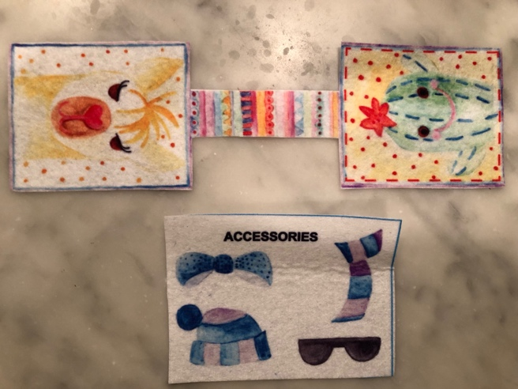
3. | - Decorate the llama and cactus with sunglasses, bow, hat and scarf (students can have fun cutting out these themselves)  NOTE – the ACCESSORIES fit both the llama and the cactus  - Add more decorative stitches to KEYCHAIN FRONT & BACK or the strap in between. | 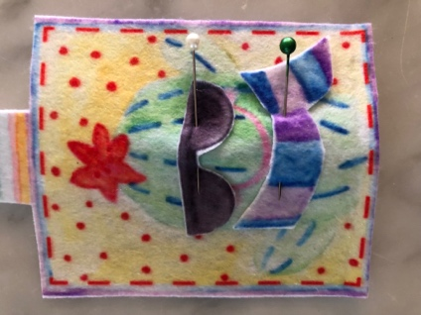  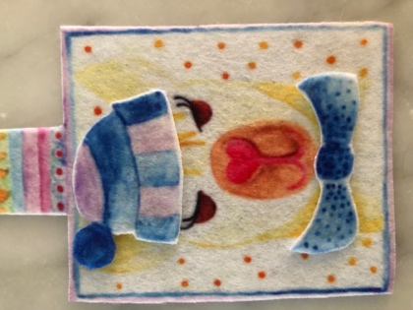
TIP! | Students will need to use a STAB STITCH (one stitch down, one stitch up) as the decorative pieces are so small.
*EXTRA WORK* | Extra activities for students who finish early:  - Add more decorative stitches to both sides of keychain  Add LEGWARMERS to LLAMA  - PIN LEGWARMERS to LLAMA legs  - Use a WHIP STITCH to stitch sides (no need to sew along top and bottom) | 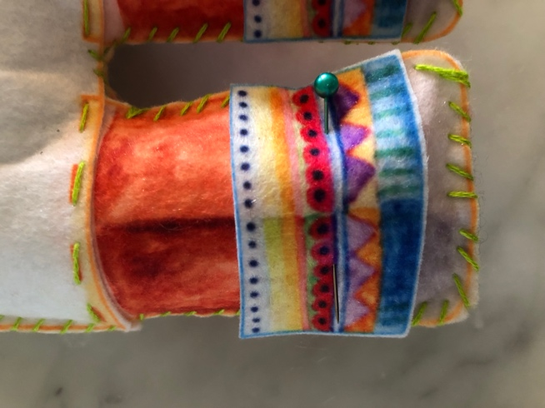  Do NOT allow any student to move on to the next step!

INSTRUCTOR PREPARATION

- CHECK:
In each student’s bag. If a child still has work to do on the LLAMA they can work on that and if they don’t get time to complete the KEYCHAIN that’s ok. Please make sure they will be able to finish the LLAMA by the end of the last class.

- THREAD and KNOT one needle per student.

REMINDERS & DEMONSTRATIONS

- Welcome Meeting & Classroom Rules  - DEMO threading a needle using the needle threader and pincushion technique.  - DEMO TYING A KNOT and LOCK STITCH  This week the demo and practice SHOULD TAKE 5 MINUTES | - PRACTICE - Give each student a pincushion, needle and needle threader and have them practice threading the needle, tying a knot around the needle and tying a knot at the end of their thread.  - REMIND students about LOCK STITCH and KNOT.
WEEK 8

WEEK 8 SEWING STEPS

1. | Reminders & Demo  DO NOT SKIP THIS STEP!
2. | Hand each student:  - KEYCHAIN  - KEYCHAIN RING
3. | - Slide KEYCHAIN RING over KEYCHAIN FRONT so that it is on the connecting strap  - MATCH KEYCHAIN FRONT & KEYCHAIN BACK  - PIN together  - STITCH around edges | 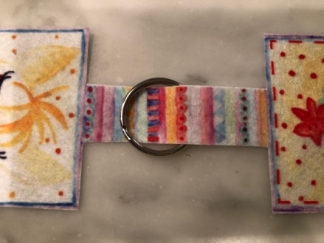
TIP! | Students need to follow the stitch lines. If they do bigger stitches they will have to stitch around a second time.
*EXTRA WORK* | Extra activities for students who finish early:  - Embellish MUG RUG FRONT & BACK

WEEKS 9 and 10

INSTRUCTOR PREPARATION

- CHECK:
In each student’s bag. If a child still has work to do on the LLAMA they can work on that and if they don’t get time to start the KEYCHAIN that’s ok. Please make sure they will be able to finish the LLAMA by the end of this last class.

- THREAD and KNOT one needle per student.

REMINDERS & DEMONSTRATIONS

- Welcome Meeting & Classroom Rules

- DEMO threading a needle using the needle threader and pincushion technique.

- REMIND students about TYING A KNOT and LOCK STITCH

This week the demo and practice SHOULD TAKE 5 MINUTES

WEEK 9 AND 10 SEWING STEPS

1. | Reminders & Demo  DO NOT SKIP THIS STEP!
2. | Hand each student:  - MUG RUG FRONT & BACK | 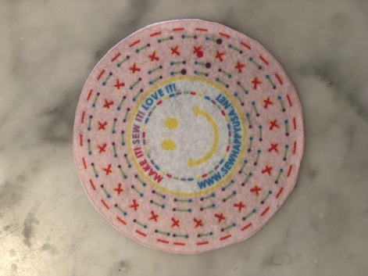  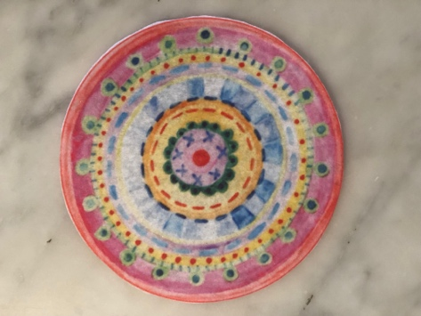
3. | - Finish any decorative stitching on both sides of MUG RUG  - With wrong sides together, PIN MUG RUG FRONT TO MUG RUG BACK, matching the edges.  Stitch around RED stitch lines. | 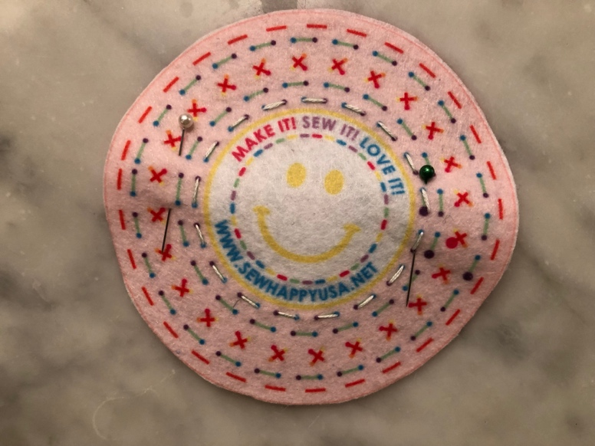
*EXTRA WORK | - If a student finishes early and has completed everything, including stitching the legwarmers on to the llama, hand out the SCRAP FABRIC (the white strips which you saved when you cut out the original design)  - FREE SEW | WELL DONE!  THE PROJECT IS COMPLETE!

